
Agenda Item 10

Report to (Board/Sub-Committee): NEL CCG Partnership Board

Date of Meeting: 8th March 2018

Subject: Integrated Assurance and Quality Report

Presented by: Eddie McCabe Assistant Director – Contracting & Performance, Jan Haxby Director of Quality & Nursing

STATUS OF THE REPORT

For Information
For Discussion 
For Approval / Ratification

PURPOSE OF REPORT: | The report advises the Partnership Board of how NELCCG are performing against;  - six domains developed for the performance dashboard;  - three domains developed for quality dashboard and;  - six domains for risk.  The dashboards are managed via the Delivery Assurance Committee, the Quality Committee and the Integrated Governance and Audit Committee.  A summary of risks with a score of 16 or above is also included.  For more detail on performance, risk and quality the latest integrated assurance report presented to the Delivery Assurance Committee and quality dashboard report presented to the Quality Committee can be found via the embedded files in the ‘Appendices / attachments’ section of this cover sheet.
Recommendations: | The Partnership Board is asked:  - to note judgements made against the domains of the dashboards  - to note the CCG Risk Management framework has been reviewed/refreshed and is shared with the committee on how we manage risks. Risk management is an increasingly important business driver and stakeholders have become much more concerned about risk. Risk may be a driver of strategic decisions, it may be a cause of uncertainty in the organisation or it may simply be embedded in the activities of the organisation. This framework aims to provide strategic direction, guidance and good management practice regarding embedding an integrated risk management approach, ensuring it is central to all CCG business, detailing clear lines of accountability and organisational responsibilities and arrangements.  - to note the Annual risk management reviews took place during June/July with the risk manager and risk assignee, with yet again a positive outcome. The purpose of these sessions are to provide the opportunity for Managers/Assignees to work together to review their risks paying particular attention to the risk ratings/internal controls and look at ways of improving our risk registers. This is also an opportunity to undertake an internal confirm & challenge and monitor static risks, for example if the risk rating of a risk hasn’t changed within the last 12 months, to evaluate whether the risk remains relevant and if so what actions will be taken.  - to note information on NELCCG CCG IAF position  - for further feedback on ways to improve the report.
Sub Committee Process and Assurance: | The Delivery Assurance Committee, the Quality Committee and the Integrated Governance and Audit Committee manage and assure the performance, quality and risks contained within these dashboards.
Implications:
Risk Assurance Framework Implications: | The dashboards and risks associated with them are managed via the Delivery Assurance Committee, the Quality Committee and the Integrated Governance and Audit Committee.
Legal Implications: | None
Equality Impact Assessment implications: | An Equality Impact Assessment is not required for this report.
Finance Implications: | There are a number of measures within the Performance Dashboard with a financial implication such as activity and Quality Premium measures, however the detail of these are dealt with separately within the Finance Report.
Quality Implications: | Quality implications are managed by the quality committee and escalated within the main body of this report.
Procurement Decisions/Implications (Care Contracting Committee): | None
Engagement Implications: | None
Conflicts of Interest | None
Strategic Objectives  Short summary as to how the report links to the CCG’s strategic objectives | - Sustainable Services  The performance, quality and risk dashboards contain a number of national and local measures that support this objective.
- Empowering People

The performance, quality and risk dashboards contain a number of national and local measures that support this objective.
- Supporting Communities

The performance, quality and risk dashboards contain a number of national and local measures that support this objective.
- Delivering a fit for purpose organisation

The performance, quality and risk dashboards contain a number of national and local measures that support this objective.
NHS Constitution: | The Performance and Quality dashboards contain measures from the NHS Constitution and the performance and risks associated with these are managed and assured through the Delivery Assurance Committee, the Quality Committee and the Integrated Governance and Audit Committee.
Report exempt from Public Disclosure | No

Appendices / attachments | 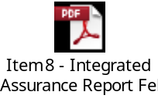

Integrated Assurance & Quality Report

Introduction
The dashboards below represent an overview of performance and quality for health and social care services across North East Lincolnshire.

The performance dashboard consists of six domains and the quality dashboard three domains that incorporate all areas that North East Lincolnshire Clinical Commissioning Group strive to improve on. A judgement has been made of the status for each domain based on the measures and intelligence underpinning them. These judgements try to balance the current position with the expected outcome at the end of the year and weightings with respect to priority. They also represent the local perspective of performance and quality for North East Lincolnshire rather than the performance against the national definition which, on occasion, covers a broader footprint. It should be noted that those issues that have an impact on the CCGs corporate performance assessment will continue to be scrutinised at the Delivery Assurance Committee. The dashboards reflect performance for the ten months of 2017-18. The Delivery Assurance Committee and Quality Committee, respectively, are asked to make a decision on the final status of the dashboards before reporting to the CCG Partnership Board. Full exception report summaries are also included for Performance (appendix A) detailing performance of indicators that are underperforming, Provider-level Quality Dashboards (appendix B), risk (appendix C) detailing risks rated as 16 or higher.
Performance Quality
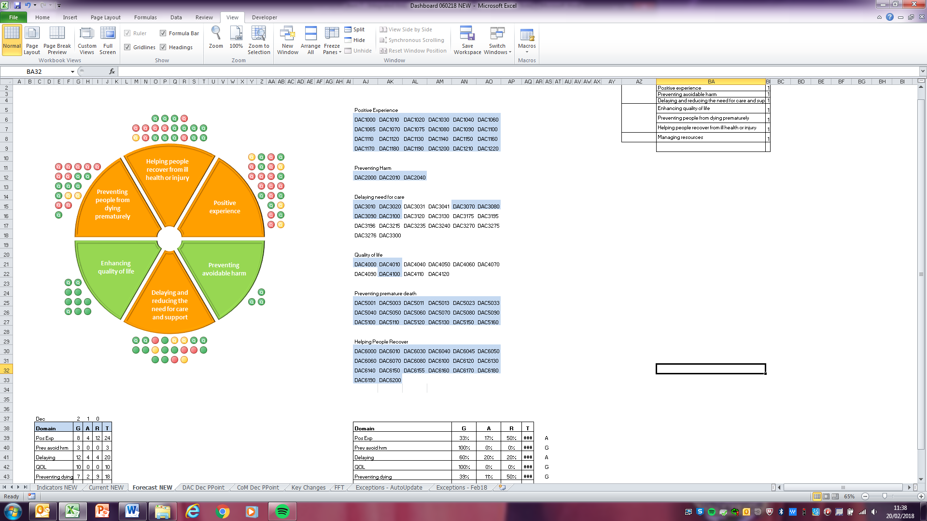
The risk heat maps are separated in to a CCG risk register and the CCGs Board Assurance Framework risks. These heat maps demonstrate the number of risks with a specific risk score. The risk summaries reflect the risk status as at 20th February 2018.

Risk Register risk profile Board Assurance Framework risk profile
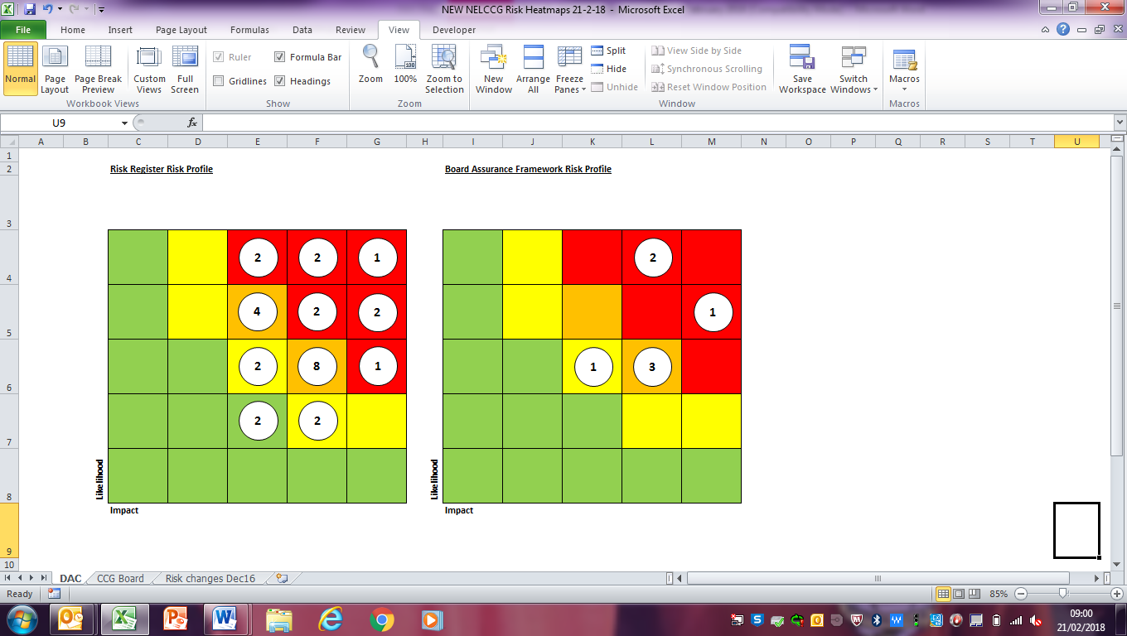

Performance Escalation

NELCCG CCG IAF position
Clinical commissioning groups (CCGs) were established on 1 April 2013 and are clinically-led organisations at the heart of the NHS system. NHS England has a statutory duty (under the Health and Social Care Act (2012)) to conduct an annual assessment of every CCG.

The CCG Improvement and Assessment Framework (IAF) has been updated for 2017/18. It builds on the IAF introduced in April 2016, which replaced both the existing CCG assurance framework and CCG performance dashboard, and was designed to provide a greater focus on assisting improvement, alongside our statutory assessment function.
The IAF aligns with NHS England’s Mandate and planning guidance, with the aim of unlocking change and improvement in a number of key areas. This approach aims to reach beyond CCGs, enabling local health systems and communities to assess their own progress from ratings published online.
The framework is intended as a focal point for joint work and support between NHS England and CCGs. It draws together the NHS Constitution, performance and finance metrics and transformational challenges and plays an important part in the delivery of the Five Year Forward View.

The tables below show NELCCG’s current position;

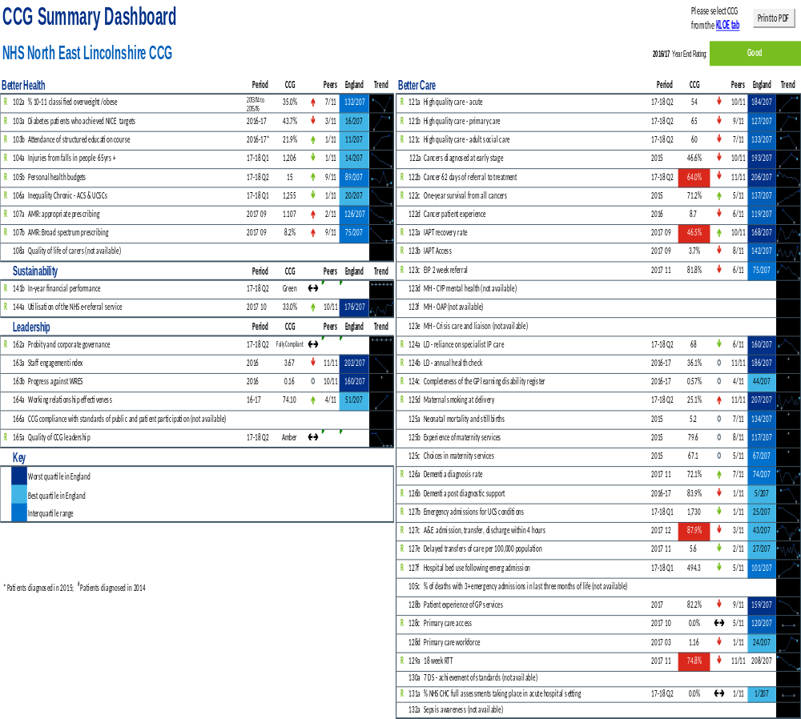

Quality Escalation

Quality Escalation

The purpose of this report is to highlight the exceptions in Quality and to escalate items from the Quality Committee to the Board.

- Enhanced Quality Surveillance
Three providers across the North East Lincolnshire healthcare system are currently rated as requiring an enhanced level of quality surveillance; these providers are NL&G, St Hugh’s and TASL. The issues and concerns that have been identified across these providers, which triggered the enhanced surveillance rating, pose an increasing risk to North East Lincolnshire residents. These factors continue to create significant challenges across the system but the CCG is working closely with all 3 providers to gain oversight and assurances, and provide support and challenge.

- Northern Lincolnshire and Goole NHS Trust (NLaG): The Trust remains in Special Measures for quality and finance and has been in special measures for almost 12 months. We anticipate that the CQC will re-inspect in the next few months to judge if there have been enough sustainable improvements to enable the Trust to come out of Special Measures.

Staffing: NL&G continues to report staffing challenges, particularly in relation to recruitment and retention of medical staff and registered nurses. The Trust wide vacancy position in nursing, nursing support, medical staffing, admin and maintenance staff are all currently high, and in some categories are the highest they have been in 24 months. The NL&G (Trust wide) turnover is currently 10.99%, against a tolerance of <9.4%.
The Trust are undertaking significant work in respect of recruitment & retention of staff but also in respect of organisational culture and its policy and practice regarding openness, anti-bullying, listening to staff etc. Recent media releases highlighted continued concerns about culture in NLG in respect of bullying culture and lack of staff support. NLaG’s CEO responded to this through the media and provided assurances that this is a priority he is taking forward.

Patients who are “Long waiters”: NL&G continues to report long waiting times across a range of specialties which is affected by reduced staffing capacity; due to high level of staff sickness and vacancy across the Trust. In light of this, NL&G has prioritised those patients in most need of clinical care and continues to focus on
• patients referred in on a 2 week wait or urgent pathway
• the number of patients waiting over 52wks
• the number of patients waiting over 40wks
Clinical Harm reviews are being undertaken in respect of people waiting across all specialties, and patients identified as coming to harm will be treated as a SI. This work has been supported by GPs in some specialties where GPs have been able to help clinically risk stratify patients – however ultimately the specialty team in NLG have made the final decision about the clinical risk to the patient and next steps.
In response to the challenges, NL&G is working with commissioners to implement a capacity and demand model, using methodology from the NHS Intensive Support Team, regarding 8 priority specialties.

NL&G also continues to report an increase in the number of patients that have waited over 52 weeks for an appointment, again due to staffing pressures and errors within the Trust’s Patient Administration System (PAS).

Commissioning for Quality and Innovation (CQUIN): NL&G did not achieve the CQUIN milestones agreed for delivery in quarter 2 17/18 and also have challenges to meeting the milestones during Q3. The Q3 position is currently being reconciled, and the final position will be submitted to the NL&G contract management meeting for review.

Mortality: The NL&G official SHMI is currently 119 (July 16 – June 17); this is +5 points from previous quarterly release, and falls into the higher than expected range. The next official SHMI position will be published in March 2018.

The Trust’s mortality rates (crude, non-elective crude, SHMI and HSMR) all show increases over the last 12 months, DPoW being higher than SGH. The top 6 specialties with highest rates for crude mortality over the last 2 years are Respiratory; Sepsis; Cardiology; Gastroenterology; General Surgery and Stroke.

Latest mortality data reflects an increase in Stroke mortality, which reached the Trust’s upper control limit of 15% in November 17 (HED SHMI of 117 in Nov 17). In response to these concerns, NL&G has developed a re-fresh of its mortality improvement plan, with new vigor from different clinical leaders; the current priorities within the draft plan include review of deteriorating patient and sepsis work streams; reinforcement of safety huddles; hydration; medical assessment process (including board rounds, specialty in-reach); multi-disciplinary Team learning from mortality and patient flow.

NEL CCG is working closely with all partners to focus on the system wide issues in respect of mortality and agree a delivery plan, some of which is based upon intelligence from recent case note reviews and highlights work needed within Care Homes, primary and community care and system wide issues.

Acute Safety Thermometer Data: The Acute Safety Thermometer indicator continues to be below the 95% threshold, since April the indicator has been between 87-89%, in September the indicator slipped to its lowest point at 83.7%.

NL&G Patient Safety Thermometer performance for pressure ulcers and VTE remained below the expected standards, in December 17. NL&G has put measures in place to improve the pressure ulcer position; including use of hybrid mattresses and implementation of a new document to improve monitoring processes. Delivery of the VTE improvement work streams continue to be overseen by the NL&G Medical Director.

Mixed Sex Accommodation Breaches: Northern Lincolnshire & Goole NHS Foundation Trust (NL&G) agreed amendments to their MSA Policy which has resulted in a significant increase. These breaches will continue until building work has been completed at DPOWH to reconfigure the C Floor and the layout to provide opportunity for single sex accommodation. In the interim, NL&G has provided privacy screens in these ward areas, to preserve patient’s dignity.

In response to these concerns, NL&G has agreed a capital development plan for these areas, although these plans are not due to commence until end of 2018. The Trust is in the process of reconfiguring their planning timeframe, to prioritise this area of work. The NL&G Chief Nurse is leading on this prioritisation work.

A and E: The Trust are reporting a deterioration in the performance position for 4 hr trolley waits. The target for delivery is extremely challenging and requires close monitoring of performance and quality outcomes. No 12 hour trolley breaches have been reported. A number of 60 minute handover breaches have been reported and will progress through the SI process.

A significant amount of partnership working is in place from the wider system, to support the delivery of safe care when there is the significant demand for beds. We are also working together to create an audit tool to help identify if harm has occurred to patients accessing A&E during periods of high escalation. This will be a retrospective review of case records of patients passing through A&E on days when the Trust is at Opel 3+, to identify if patients are coming to harm and where the risks are for patients. This work only recently commenced and is currently testing the audit tool on a small sample size but will share the learning across.

Diagnostics: During February DPOWH experienced failure of its CT scanner at DPOWH, and a second mobile unit had to be brought onto site from SGH as an interim. NLG needed to divert certain cases to Scunthorpe if they were high risk and needed the support of EMAS to do this. This affected patient experience and also created a risk to patient safety which NLG had to manage.

The JAG accreditation team will visit the Grimsby Endoscopy service in April 18. The visit will determine whether the service will be awarded accreditation. A similar visit will be undertaken at the Scunthorpe Endoscopy service in September 2018.

Maternity & Paediatric/neonatal services: NLG (and other Trusts nationally) are being offered additional support in respect of maternity services, due to the CQC judgement of maternity and overall CQC rating. Local discussions concluded that there is already a significant amount of additional support into maternity in NLG and that currently there would be more benefit from a focus in Obstetrics and an Obstetrician with a track history of undertaking similar work to improve outcomes has already started working with peers in NLG.

A group including NLG and NL & NEL CCG’s has a strategic focus on the future model of maternity services, and is linked into maternity work across the STP. This should help shape the future model and service design for maternity services.

Concerns and Noise in the System is emerging around paediatrics and we have shared with the Trust the initial concerns raised by all partners. The majority of concerns appear to be at DPOWH although there is a specific case by ER CCG of a child death that is being investigated.

We have agreed a number of actions with CCG’s in NL & ER: 1. a site visit is planned to paediatrics to gain assurance re the issues of concerns, and 2. we will develop a service specification that outlines the expected paediatric service at NLG. NLG have already identified that there are cultural issues in paediatrics at DPOWH and are already addressing these – these are different issues though to what we have identified as concerns. NLG are in agreement with our actions and we aim to work with them to address the gaps in service quality.

- Thames Ambulance Service Limited (TASL)
Concerns continue regarding the lack of organisational structure to support governance arrangements in TASL and regarding the efficiency of service delivery and experience of service users. The CCG continues to work with NL CCG and TASL to address the concerns and reduce risks. The CCG has identified significant concerns across their intelligence systems about service user dissatisfaction with the service, specifically length of call time for booking the service, appropriateness of the transport vehicle sent, failing to attend, tardiness of vehicle arrival which impacts routine appointments. Site visits took place to the Scunthorpe site on 19th February and in Grimsby on 20th February 2018 which raised a number of issues we are working with TASL on.

In response to these concerns, the 2 CCGs in NEL & NL have completed a Quality Risk Profile to determine the current level of risk. The final draft version of the QRP is currently being reviewed but has already been discussed at a Quality Review Meeting held by NHSE, with intentions of further follow-up meetings.

NLCCG submitted a Contract Performance Notice to TASL in October 2017. A Recovery Action Plan (RAP) has been implemented by TASL, in conjunction with commissioners; progress against the RAP is reviewed as part of the contract management meeting.

- HMT St Hugh’s
St Hugh’s has required a steady increase of support during 2017 to help them achieve good quality standards and there is more work to do, however they work openly with commissioners and are progressing their action plans.

The CQC completed a comprehensive inspection at St Hughs in August 2017 and published the report in December 2017 with an overall rating of Requires Improvement – with a break-down of Requires Improvement for Safe, Effective, and Well-led, and Good for Caring and Responsive. We have been working closely with St Hughs during 2017, and St Hughs have been responsive and willing to work on their areas for improvement.

The CQC found that some improvements from previous inspections had not been completed/ implemented. They found that medicines management and record keeping was not in line with required standards, some staff did not have evidence of required competencies, there was limited evidence of nutritional screening in the clinical records, staff continued to use different pain assessment scoring systems to assess pain levels and some care pathways did not reference national or professional guidance.

2 Serious Incidents occurred at St Hughs during October 2017 – both of which were never events. The CCG is working closely with St Hughs regarding SI and incident reporting and management.

The CCG is also working with St Hughs to demonstrate their compliance with safeguarding standards.

The CQC undertook an unannounced site visit within the last few weeks and we are awaiting any further information from this visit.

- NEL Wound Care Initiative with TELER system shortlisted for a National Award at the Journal of Wound Care Awards
We eagerly anticipate the outcome of the 2nd of March Awards Ceremony and acknowledge the great work of all healthcare staff and commissioners involved in implementing, leading and delivering the innovative Wound Care Initiative.

- Learning from a multi-stakeholder serious incident
NELCCG has identified significant learning from a NELCCG reported and investigated Serious Incident which intersected a number of services, which the learning will be shared locally, across Northern Lincolnshire and at the Regional Quality Leads Meeting. The Serious Incident encompasses learning concerning the Mental Capacity Act and end of life reviews.

- Noise in the System Process
We have initiated and held NIT’s meetings to share intelligence, conduct deep dives and agree action I respect of CCL (based on concerns raised to the Board in Januarys meeting), cardiology and paediatrics at NLG. The meetings have been extremely useful to focus and prioritise work streams.

We are also noting a “theme” emerging from a number of safeguarding cases over the last 12-18 months, of vulnerable people not always being recognised for their vulnerabilities, and supported in what might seem to be the best way possible. This appears to be connected to what could be perceived as “unwise decision making” by the adults that are vulnerable. This is a theme which requires further exploration and which we have escalated to the Safeguarding Adult Board (SAB) and the Local Safeguarding Children Board (LSCB) where these cases will be investigated either as a Safeguarding Adult Review (SAR) or an SI, and some are also a police investigation.

Items for Escalation from the Quality Committee

Members of the NELCCG Quality Committee, which took place in February, identified three items for escalation to the Board, these items are summarised below:

- Quality Team and Engagement Team work stream to respond to concerns raised through Engagement activity and Accord
The Quality Committee members recognised the good work undertaken between the Quality Team and Engagement team to align processes to capture and respond to noise in the system, and to ensure the CCG is able to respond to concerns and issues raised through Accord.

- Northern Lincolnshire and Goole NHS Trust – Maternity and Paediatrics
A Quality Risk Profile has been completed for Maternity and Paediatric Services at NLaG, catalysed by quality indicators which triggered escalating concerns. Local commissioning action has been taken to challenge, support and facilitate improvement in the indicators which are not meeting a satisfactory quality standard.

- North East Lincolnshire Mortality Group
The NELCCG Mortality Group has been revised following the restructure of NLaG’s Mortality Group. NELCCG are leading and facilitating the North East Lincolnshire Mortality Group and have welcomed membership from key stakeholders in North East Lincolnshire, including Public Health, Primary Care, Commissioning and NLaG representatives. The group are agreeing clear terms of reference to ensure a focused remit of the group.

Appendix A - Performance Exception Summary
Code | Indicator | Quality Measure? | Latest period |  |  |  | Year to date |  |  | Year End Forecast
Code | Indicator | Quality Measure? | Period | Target | Value | Status | Target | Value | Status | Year End Forecast
Positive experience
DAC1000 | Total time in A&E: four hours or less | Yes | January 2018 | 85.91% | 86.22% |  | 84.83% | 86.48%
DAC1020 | Cancelled Operations offered binding date within 28 days | Yes | Q3 2017/18 | 5.69% | 5.17% |  | 0.96% | 7.97% | 
DAC1040 | Numbers of unjustified mixed sex accommodation breaches | Yes | January 2018 | 0 | 36 |  | 0 | 264
DAC1065 | Friends & Family - Ambulance - % Who would recommend 'SAT' service | Yes | December 2017 | 86.76% | 62.5% |  | 94.45% | 87.72%
DAC1070 | Friends & Family - Ambulance Response (PTS) | Yes | December 2017 | 0.45% | 0.53% |  | 0.6% | 0.54%
DAC1075 | Friends & Family - Ambulance Response (SAT) | Yes | December 2017 | 0.09% | 0.04% |  | 0.12% | 0.08%
DAC1080 | Friends & Family - AAE % Who would recommend service | Yes | December 2017 | 85.48% | 83.36% |  | 86.8% | 78.7%
DAC1090 | Friends & Family - AAE Response (NLAG) | Yes | December 2017 | 11.62% | 5.76% |  | 12.67% | 6.61%
DAC1110 | Friends & Family - Inpatient Response (NLAG) | Yes | December 2017 | 22.06% | 10.34% |  | 25.44% | 12.7%
DAC1120 | Friends & Family - Outpatient - % Who would recommend service | Yes | December 2017 | 94.01% | 84.15% |  | 93.76% | 85.99%
DAC1130 | Friends & Family - Outpatient Response | Yes | December 2017 | 4.95% | 0.26% |  | 6.29% | 0.23%
DAC1150 | Friends & Family - Community Response (CPG) | Yes | December 2017 | 3.32% | 0.81% |  | 3.6% | 1.11%
DAC1180 | Friends & Family - Maternity - Combined % Who would recommend | Yes | December 2017 | 96% | 94.23% |  | 95.95% | 95.92%
DAC1190 | Friends & Family - Maternity Response (NLAG) Birth | Yes | December 2017 | 19.16% | 15.66% |  | 22.91% | 15.06%
DAC1210 | Proportion of GP referrals made by e-referrals | Yes | November 2017 | 80% | 33.03% |  | 80% | 33.03%
DAC1220 | Overall Experience of Making a GP Appointment | Yes | 2016/17 | 73.26% | 71.53% |  | No data available for 2017/18
Preventing avoidable harm
No exceptions
Delaying and reducing the need for care and support
DAC3031 | Permanent admissions 18-64 to residential and nursing care homes | No | December 2017 | 1.25 | 1 |  | 11.25 | 10
DAC3070 | Delayed transfers of care (delayed days) from hospital per 100,000 population (aged 18+). | Yes | December 2017 | 218.53 | 143.43 |  | 1999.77 | 1936.25
DAC3080 | Delayed transfers of care (delayed days) from hospital per 100,000 population (aged 18+) which are an NHS responsibility | Yes | December 2017 | 150.6 | 136.25 |  | 1524.31 | 1719.52
DAC3175 | Total Elective Spells (Specific Acute) | No | November 2017 | 2475 | 2690 |  | 19014 | 20546
DAC3215 | Consultant Led First Outpatient Attendances (Specific Acute) | No | November 2017 | 3712 | 4076 |  | 28518 | 33082
DAC3235 | Consultant Led Follow-Up Outpatient Attendances (Specific Acute) | No | November 2017 | 7333 | 8277 |  | 56330 | 61478
DAC3276 | Total Other Referrals made for a First Outpatient Appointment (G&A) | No | December 2017 | 1727 | 1659 |  | 17087 | 18145
DAC3300 | Breastfeeding Initiation Rates | No | November 2017 | 62.22% | 53.8% |  | 62.22% | 56.7%
Enhancing quality of life
No exceptions
Preventing people from dying prematurely
DAC5001 | ARP Category 1 Mean Response Time – Calls from people with life-threatening illnesses or injuries | Yes | December 2017 | 00:07:00 | 00:09:38 |  | 00:07:00 | 00:08:36
DAC5003 | ARP Category 1 90th centile response time – Calls from people with life-threatening illnesses or injuries | Yes | December 2017 | 00:15:00 | 00:17:13 |  | 00:15:00 | 00:15:21
DAC5011 | ARP Category 2 Mean Response Time – Emergency calls | Yes | December 2017 | 00:18:00 | 00:39:29 |  | 00:07:00 | 00:30:25
DAC5013 | ARP Category 2 90th centile response time – Emergency Calls | Yes | December 2017 | 00:40:00 | 01:26:09 |  | 00:15:00 | 01:05:23
DAC5023 | ARP Category 3 90th centile response time – Urgent Calls | Yes | December 2017 | 02:00:00 | 04:00:09 |  | 02:00:00 | 03:15:53
DAC5033 | ARP Category 4 90th centile response time – Less Urgent Calls | Yes | December 2017 | 03:00:00 | 04:42:22 |  | 03:00:00 | 03:53:21
DAC5040 | Ambulance 30 minute average turnaround time target - DPOW | No | December 2017 | 30 mins | 36 mins |  | 30 mins | 38.32 mins
DAC5110 | Cancer 62 Days Referral to Treatment (GP Referral) | Yes | December 2017 | 83.3% | 82.14% |  | 80% | 71.82%
DAC5120 | Cancer 62 Days Referral to Treatment (Screening Referral) | Yes | December 2017 | 90% | 71.4% |  | 90% | 79.2%
DAC5130 | Cancer 62 Days Referral to Treatment (Consultant Upgrade) | Yes | October 2017 | 90% | 100% |  | 90% | 66.67%
DAC5150 | Summary Hospital Mortality Index (SHMI) - NLAG | Yes | June 2017 | 100 | 118.54 |  | 100 | 118.54
Helping people recover from ill health or injury
DAC6040 | RTT - Number of completed admitted RTT pathways | Yes | January 2018 | 859 | 1174 |  | 8203 | 10230
DAC6045 | RTT - Number of completed non-admitted RTT pathways | Yes | January 2018 | 2651 | 3742 |  | 25310 | 28495
DAC6050 | RTT - Number of new RTT pathways (clock starts) | Yes | January 2018 | 4402 | 5454 |  | 42018 | 45421
DAC6060 | RTT - Incomplete Patients: % Seen Within 18 Weeks | Yes | January 2018 | 80% | 73.79% |  | 80% | 75.3%
DAC6070 | RTT – No. waiting on incomplete pathway 52+ wks | Yes | January 2018 | 0 | 39 |  | 0 | 362
Appendix B – Provider-level Quality Surveillance Ratings
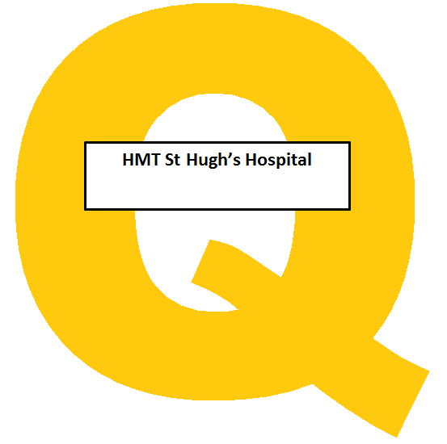
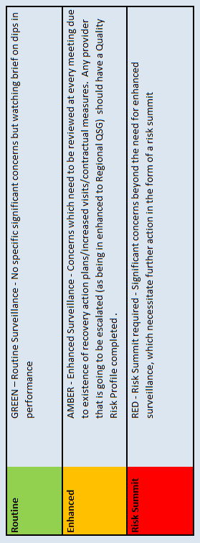
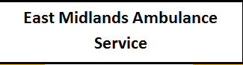
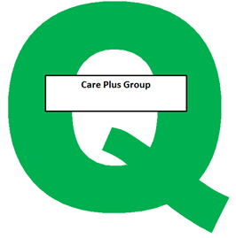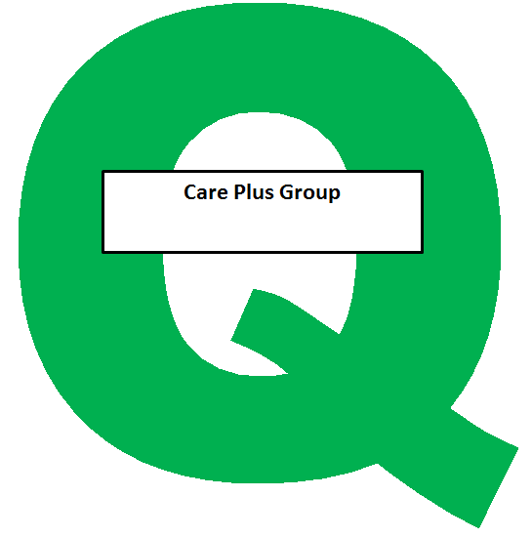
Appendix C – Risk Exception Summary

Section 1 – Board Assurance Framework
The table below reflects risks rated as 15+ (high to significant) on the assurance framework as at 20th February 2018

Component 2: Better Care - How is the CCG faring with its care redesign, performance of constitutional standards, and its outcomes, including in important clinical areas?
Risk Code | Risk Summary | Risk Assignee | Initial Risk Rating | Current Risk rating | Current Risk Trend Icon | Last reviewed date | Control |  | Notes & History Latest Note
CCG-BAF.2002 | Risks in delivery of key annual performance indicators and standards including constitutional standards | Martin Rabbetts | 12 | 20 |  | 15 Feb 2018 | Assurance on controls | Regular reporting in to Partnership Board, Delivery Assurance Committee, CoM and the operational leadership team. | 14/02/18 Martin Rabbetts reviewed this risk and advised that the rating should remain as it stands. However the positive assurances and gaps in assurances were amended as follows:  Positive assurances - A&E four hour wait performance saw significant improvement in quarter 3 of 2017-18 and met the national expectation of 90%. This is a measure that has not met this level of performance for over a year. Q4 performance has dipped again but the trust are still performing better than the average. The CCG also recently received the best available ratings for diabetes services (Outstanding) and Patient & Community Engagement (Green Star)  Gaps in assurances - Some improvements have been noted around A&E and Cancer Waiting Times performance but this needs to be delivered consistently to gain greater assurances.
 |  |  |  |  |  |  | Positive Assurances | July 2017 NHS E have acknowledged the CCG is taking an active leadership role to address the issues in relation to NLaG.  Further assessment of six clinical areas in the CCG Improvement and Assessment Framework demonstrate that NEL are in the top five CCGs in the country, although improvement is required in three.  NHSE's overall assessment of the CCG in the improvement and assessment framework was ‘Good’.  In particular A&E four hour wait performance saw significant improvement in quarter 3 of 2017-18 and met the national expectation of 90%. This is a measure that has not met this level of performance for over a year. Q4 performance has dipped again but the Trust are still performing better than the average.  2016/17 Year end position of ASC targets was positive and the Local Account was positive.  The CCG also recently received the best available ratings for diabetes services (Outstanding) and Patient & Community Engagement (Green Star)
 |  |  |  |  |  |  | Gaps in controls | None
 |  |  |  |  |  |  | Gaps in assurances | We recognise that there is significantly increased oversight and assurance mechanisms in place to oversee NLaG performance however gaps will remain until we start to see improvements feeding through. Some improvements have been noted around A&E and Cancer Waiting Times performance but this needs to be delivered consistently to gain greater assurances.

Risk Code | Risk Summary | Risk Assignee | Initial Risk Rating | Current Risk rating | Current Risk Trend Icon | Last reviewed date | Control |  | Notes & History Latest Note
CCG-BAF.2003 | NLaG Service Sustainability | Helen Kenyon | 20 | 20 |  | 17 Jan 2018 | Assurance on controls | Chief Executive representation from NL & NEL CCGs and NLaG on the System Improvement Board (SIB)  The CCG's Acting Chief Finance Officer represents the CCG on the aligned incentive contract group | 17/01/2018 - Helen Kenyon updated the risk as follows:-  All of the sub groups have now been operational for a number of months and are effectively working, engagement is good, constructive change and questioning is taking place and across a number of areas performance is approving:  . NLG achieved its 90% A&E 4 hour wait performance requirement, which was a significant improvement on the same  period the previous year. The Patch has also received central funding to support its improvement trajectory.  . Within Planned care, whilst RTT performance has not yet improvement the trust has now completed capacity mapping  which will help it to determine its requirements for the longer term in conjunction with the CCG, Cancer 62 day wait  performance has improved.  In addition to the above a Humber acute review group has been established to take forward, oversee and drive the work that is required between NLG and Hull Trust to ensure that fragile services and specialist services can continue to delivered, and in a sustainable manner.  Internal Controls and Assurances/gaps in controls have been updated accordingly.
 |  |  |  |  |  |  | Positive Assurances | System Improvement Board whose membership includes NHS England and NHS Improvement.  NEL CCG received positive feedback in the second quarter of 2017 at its assurance meeting with NHS England  The STP In-hospital Working Group is starting to work more effectively and is addressing issues across providers  The ACP is getting more involved and starting to come up with proposals to divert activity and release pressures
 |  |  |  |  |  |  | Gaps in controls | All of the controls listed have only been established very recently and need time to bed in before their full effectiveness can be evaluated. All of the groups have now been operating for a number of months, and improvements in quality and performance are starting to be seen
 |  |  |  |  |  |  | Gaps in assurances | All of the assurances listed have only been established very recently and need time to bed in before their full effectiveness can be evaluated  Lack of consistent leadership presence from NLaG due to a number of time limited interims in place

Component 4: Leadership - How good is the quality of the CCG's leadership and the quality of it's plans? How does the CCG work with its partners and the governance arrangements that the CCG has in place to ensure it acts with probity, for example, in managing conflicts of interest?

Risk Code | Risk Summary | Risk Assignee | Initial Risk Rating | Current Risk rating | Current Risk Trend Icon | Last reviewed date | Control |  | Notes & History Latest Note
CCG-BAF.4001 | Failure to consult in line with statutory requirements on significant service change/redesign which could lead to a breach of statutory duty | Lisa Hilder | 3 | 20 |  | 09 Jan 2018 | Assurance on controls | Monitoring of outputs by the Health Overview and Scrutiny Committee | 8/1/18 Lisa Hilder advised no changes are necessary.
 |  |  |  |  |  |  | Positive Assurances | NHS England annual report has been rating the CCG as positive for comms and engagement. | 8/1/18 Lisa Hilder advised no changes are necessary.
 |  |  |  |  |  |  | Gaps in controls | Some limited staff member gaps in understanding organisational processes around consultation for significant service change/redesign | 8/1/18 Lisa Hilder advised no changes are necessary.
 |  |  |  |  |  |  | Gaps in assurances | N/A | 8/1/18 Lisa Hilder advised no changes are necessary.

Section 2 - Risk Register
The table below reflects risks rated as 15+ (high to significant) on the risk register as at 20th February 2018

Guidance Component 2: Better Care - How is the CCG faring with its care redesign, performance of constitutional standards, and its outcomes, including in important clinical areas?

Risk Code | Risk Summary | Risk Assignee | Original Risk Rating | Current Risk Rating | Current Risk Trend | Last Reviewed Date | Internal Controls | Description of Control | Latest Update
CCG-RR.2005 | RTT Performance | Pauline Bamgbala | 20 | 25 |  | 15 Feb 2018 | CCG-RR.2005a Performance Reporting | Robust performance reporting is produced for the Service Lead to act upon and is monitored at Delivery Assurance Committee with escalation to CoM and Partnership Board. | 15/02/18 Pauline Bamgbala advised:  RTT – December 2018 – Covers all providers for our patients. Performance for NLaG alone is currently 69.3%  Latest performance for incomplete pathways is 73.5% against target of 92%. Performance fell slightly from November. Main specialities of concern are:  Neurology (under 57%), ENT 61.1%, thoracics 62.4%, ophthalmology 64.1, cardiology 64.5  NLaG have produced plan for recovery by end of May.  Currently there are 19 patients waiting over 52 weeks for treatment as at December.  NLaG held a Capacity & Demand workshop on 24 January 2018. Specialities included in review are: Urology/ENT/Opthalmology/Colorectal/Cardiology/ Gastroenterology/Neurology/Respiratory. Action plans have been developed to address shortfalls. This will be monitored via the Planned Care Board.  Right Care: Gastro Pathway redesign awaiting NLaG sign off at end of February. Cardiology: agreeing integrated model Respiratory: in-reach started at DPOW and looking to identify COPD patients  Cancer:  62 day performance all providers is 82.1% for December – just below target of 83.3%  Five patients waiting over 62 days in December. Only one flagged as result of capacity issues – remainder are as result of patient choice or complex pathways  2ww still exceeds target  No breaches in December for 31 day decision to treat  At the beginning of January, 149 patients without diagnosis are waiting over 62 days, and 36 with diagnosis. This situation is being monitored via the Planned Care Board.
 |  |  |  |  |  |  | CCG-RR.2005c System wide transformation group establised | RTT has been established which will feed into the System Transformation Board and the System Improvement Board. Senior leadership at those meetings with clinically led planning to redesign services for optimum efficiency and effectiveness.  Clinical engagement has been secured from both the Trust and the CCG.  Structured programme approach to be taken using Right Care principles. Initial priority areas identified are respiratory, cardiac and gastro.
 |  |  |  |  |  |  | CCG-RR.2005e Clinical Harm Review Groups | There are two clinical harm review groups (one at NLaG and one external). They both meet on a monthly basis and Jan Haxby is a member of both groups.

Risk Code | Risk Summary | Risk Assignee | Original Risk Rating | Current Risk Rating | Current Risk Trend | Last Reviewed Date | Internal Controls | Description of Control | Latest Update
CCG-RR.2004 | Failure to achieve Accident and Emergency 4 hour targets | Andy Ombler | 16 | 20 |  | 13 Feb 2018 | CCG-RR.2004b Action Plans | Action plans focussing on all issues with potential impact on 4 hour A&E wait performance. The action plan has been revised to take into account the ECIP findings and recommendations. | 12/02/18 – Andy Ombler advised NLaG achieved the Q3 target of 90% with a performance of 90.6% with DPoW contributing ~ 87.5% however January performance was impacted by winter pressures with the Trust achieving 86.1% with DPoW contributing 83.2%.  Performance continues to be monitored by the A&E Delivery Board as does the key escalation and develop initiatives established both in and out of hospital to support performance. Key actions taken have been the continued development of a single Integrated Discharge Team with a focus on discharging medically optimised patients under D2A and the escalation response of providers (CCL, FOCUS, CPG) particularly in support of A&E to complement the co-located GP services.  Risk rating is being maintained due to prevailing pressures and NLaG currently is a recovering system with a target of 90% for Q3 and Q4.
 |  |  |  |  |  |  | CCG-RR.2004c A&E Delivery Board | A&E delivery board established as part of a national requirement to ensure system wide ownership and delivery against the A&E target required.

Risk Code | Risk Summary | Risk Assignee | Original Risk Rating | Current Risk Rating | Current Risk Trend | Last Reviewed Date | Internal Controls | Description of Control | Latest Update
CCG-RR.2003 | On-going failure to meet Clinical Handover time targets for EMAS patient delivery at DPoW A&E | Andy Ombler | 8 | 15 |  | 13 Feb 2018 | CCG-RR.2003a CCG | Performance is monitored by the CCG and reported to the A&E Delivery Board. Monitoring only. | 12/02/2018 – Andy Ombler advised the December handover performance remained at similar levels to November with a marginal deterioration of pre-clinical handover time balanced by a similar improvement in post-clinical handover time.  The current risk rating remains the same with ongoing failure to meet the requirement and the level of impact based on detriment to patients and on impact to EMAS on the time lost due to resources waiting for handover to be completed.  Controls are currently limited to monitoring in the knowledge of the prevailing winter pressures and the engagement between EMAS and NLaG on escalation processes to be employed if handover deteriorates.

Risk Code | Risk Summary | Risk Assignee | Original Risk Rating | Current Risk Rating | Current Risk Trend | Last Reviewed Date | Internal Controls | Description of Control | Latest Update
CCG-RR.2012 | Patient Transport Services - operational resilience and quality of service | Andy Ombler | 20 | 15 |  | 13 Feb 2018 | CCG-RR.2012a Additional capacity | To mitigate PTS capacity limitations being a factor in delayed discharges it has been agreed through the A&E Delivery Board to increase capacity through enacting the contracted winter vehicle capacity from Thames and commissioning additional capacity from Amvale. Will require review before end March 2018. | 12/02/18 – Andy Ombler advised that operational problems through January did not subside. The overall effectiveness and capacity of discharge transport continues to be mitigated by the additional capacity commissioned (Risk control (a) ) through Amvale and TASL and the TASL winter pressures vehicle. Under contract notice, a Recovery Action Plan has defined a trajectory of KPI performance improvement until the end of March 2018. Key decisions are required imminently to address the service changes with TASL and Amvale that take effect end March ‘18 (end of some of the Amvale and TASL services as currently arranged) and with the implications and next actions should there be failure of TASL to meet the contract notice improvement trajectory. The approach of NLCCG is also noted as their governing body considers contract termination.  The Risk rating remains the same based on prevailing performance and contract performance regime in place.
 |  |  |  |  |  |  | CCG-RR.2012b Quality and patient safety | There have been significant concerns around patient safety and service quality since contract start. The CCG quality team, CQC and a partnership group of Thames commissioners across the region continue to have significant levels of involvement in monitoring these issues.
 |  |  |  |  |  |  | CCG-RR.2012c Financial sustainability | Since contract started concerns have been raised on a number of occasions relating to the financial sustainability of the provider. The CCG continues to monitor the situation.

Guidance Component 3: Sustainability - How is the CCG remaining in financial balance and securing good value for patients and the public from the money it spends?

Risk Code | Risk Summary | Risk Assignee | Original Risk Rating | Current Risk Rating | Current Risk Trend | Last Reviewed Date | Internal Controls | Description of Control | Latest Update
CCG-RR.3017 | Capacity to undertake required engagement and consultation activities | Sally Czabaniuk | 20 | 20 |  | 05 Jan 2018 | CCG-RR.3017a Line management | Constant reprioritisation of work. | 05/01/18 Sally Czabaniuk advised there have been no changes since her previous update and the situation remains the same.
 |  |  |  |  |  |  | CCG-RR.3017b Discussion at SCU | Reprioritisation of work

CCG-RR.3003 | Adult ADHD Pathway breakdown | Leigh Holton | 20 | 16 |  | 09 Feb 2018 | CCG-RR.3003a Council of Members (CoM) | Quarterly report to CoM | 08/02/18 Leigh Holton advised that whilst financial challenges continue we are exploring an alternative model of service, visit planned for 9/2/18 to inform development of further options. Looking to identify other options to reduce risk with little success. Current progress still falls short of implemented changes to the system so we are unable to lower the risk rating at this time.
 |  |  |  |  |  |  | CCG-RR.3003b PALs monitoring logs | Monitoring through logs of concerns via PALs

CCG-RR.3016 | Mental Health SilverLink Computer System (Non-Disclosure Applies) | John Mitchell | 15 | 15 |  | 02 Feb 2018 | CCG-RR.3016a NAViGO Project Team. Project Plan in place which is overseen by the Programme Manager | A NAViGO project team with a CCG representative (Associate Director IT) is to be established | 02/02/18 – John Mitchell advised a new Clinical system has been selected & we are waiting on confirmation that the STP has provided funding –JM chasing.
 |  |  |  |  |  |  | CCG-RR.3016b Veeam back up of data | Veeam backup of data and servers at 3am every day
 |  |  |  |  |  |  | CCG-RR.3016c Real time replication | The SilverLink databases are replicated in real time from Care Plus Group primary datacentre to Care Plus Group secondary datacentre.
 |  |  |  |  |  |  | CCG-RR.3016d Programme Manager | Programme Manager now in place. This is funded by CCG, his role is to manage the project and the implementation of procurement.

Guidance Component 4: Leadership - How good is the quality of the CCG's leadership and the quality of it's plans? How does the CCG work with its partners and the governance arrangements that the CCG has in place to ensure it acts with probity, for example, in managing conflicts of interest?

Risk Code | Risk Summary | Risk Assignee | Original Risk Rating | Current Risk Rating | Current Risk Trend | Last Reviewed Date | Internal Controls | Description of Control | Latest Update
CCG-RR.4007 | eMBED IT Core Contract Delivery | John Mitchell | 25 | 20 |  | 02 Feb 2018 | CCG-RR.4007a Contract in place | Contract, detailing service spec and SLA in place. Currently meeting contractual IT KPIs. | 02/02/18 John Mitchell advised eMBED has assigned the Humber Locality with a dedicated SDM in order to ensure a more prompt response.  JM has started to look at a long term IT support strategy.
 |  |  |  |  |  |  | CCG-RR.4007b Contract Management Arrangements in place | Regular monthly contract monitoring meeting in place with the CCG and eMBED. Attendees are John Mitchell and Eddie McCabe and Julie Wilson attends as required
 |  |  |  |  |  |  | CCG-RR.4007c Programme and Project Plans | Programme controls in place, used to manage the Project and Programmes. eMBED able to provide tracking tool.  The CCG has taken steps to monitor programme delivery on a monthly basis via the Strategy Board.
 |  |  |  |  |  |  | CCG-RR.4007d Risk Management in Place | Part of programme management of controls and is also picked up by the Strategy group.
 |  |  |  |  |  |  | CCG-RR.4007e Local Primary Care Strategy Group | A locally focused strategic group has been formed to provide a gateway for approving use of project days and monitoring progress on delivery. This control is scored at partially effective as the group is currently in its initiation phase.

Risk Code | Risk Summary | Risk Assignee | Original Risk Rating | Current Risk Rating | Current Risk Trend | Last Reviewed Date | Internal Controls | Description of Control | Latest Update
CCG-RR.4017 | Establishment of the Accountable Care Partnership in North East Lincolnshire | Eddie McCabe | 25 | 20 |  | 17 Jan 2018 | CCG-RR.4017a ACP Shadow Board | The CCG is a member of the board. Regular meetings take place to discuss the development of the ACP | 17/01/2018 - Helen Kenyon updated the risk as follows:-  Additional programme support (Kim Cook) has now been engaged to support both the work of the CCG and council as the commissioners and the providers of the service. Letters were issued to all providers immediately prior to Christmas asking each organisation to sign up im principle to sign up to work under an alliance contract for Integrated Urgent Care. Sign up in principle has been sent back from a number of providers already.  A legal briefing has been received by the CCG and council to provide support in relation to next steps and mitigating against challenge.  Risk assigned to Eddie McCabe as requested by Helen.
 |  |  |  |  |  |  | CCG-RR.4017b ACP Workplan in place | Work plan in place to provide timelines and oversight on progress of the ACP
 |  |  |  |  |  |  | CCG-RR.4017c Programme Manager appointed | A Programme Manager has been appointed to support overall delivery of the programme

Risk Code | Risk Summary | Risk Assignee | Original Risk Rating | Current Risk Rating | Current Risk Trend | Last Reviewed Date | Internal Controls | Description of Control | Latest Update
CCG-RR.4004 | The DoLS system is unable to cope with the increasing number of requests for authorisation | Bruce Bradshaw | 16 | 16 |  | 09 Feb 2018 | CCG-RR.4004a Monitoring of activity at DAC and Safeguarding Board | The risks are monitored as part of the strategic plan and reviewed on a regular basis by the Chair (Jan Haxby NELCCG) and via the Safeguarding Adults Operational Leadership Group. | 08/02/18 Bruce Bradshaw reviewed this risk and further amended control 4004c to reflect the contract variations being reviewed to ensure that BIA’s employed by organisations other than FOCUS are available for use on the Duty Rota. All other aspects of the risk remain the same.
 |  |  |  |  |  |  | CCG-RR.4004b Strategic Mental Capacity Group | The Group monitors strategic change and works jointly with the CCG and providers. Group membership is led by CCG representation with other members coming from key stakeholders and voluntary sector. The role and function of this group is being reviewed to try and share and target the work more effectively  Reports from this group go to the CCG Quality Committee and Operational Leadership Group.  It has been agreed that this group will be re-formed to be an official subgroup of the Safeguarding Adults Board.
 |  |  |  |  |  |  | CCG-RR.4004c Additional capacity to support delivery | Increasing recruiting and training best interest assessors across the local health and social care economy. Increase in staffing to support operational delivery and advice. Contract variations being reviewed to ensure that BIA’s employed by organisations other than FOCUS are available for use on the Duty Rota.
 |  |  |  |  |  |  | CCG-RR.4004d Joint working with NELC legal team | Help and support to develop and deliver a process for applications to the court of protection for deprivations in non standard settings.  Providing front end legal advice to practitioners.

