Integrated Assurance Report

Introduction

The dashboards below represent an overview of performance and risk for health and social care services across North East Lincolnshire.

The performance dashboard consists of seven domains that incorporate all areas that North East Lincolnshire Clinical Commissioning Group strive to improve on. A judgement has been made of the status for each domain based on the performance measures underpinning them. These judgements try to balance the current position with the expected outcome at the end of the year and weightings with respect to priority. They also represent the local perspective of performance for North East Lincolnshire rather than the performance against the national definition which, on occasion, covers a broader footprint. It should be noted that those issues that have an impact on the CCGs corporate performance assessment will continue to be scrutinised at the Delivery Assurance Committee. The Delivery Assurance Committee is asked to make a decision on the final status of the dashboard before reporting to the CCG Partnership Board. The risk dashboards are separated in to a CCG risk register and the CCGs Board Assurance Framework risks. These dashboards demonstrate the number of risks with a specific risk score. The performance dashboard reflects performance for the first six months of 2015-16 and the risk summaries reflect risk status as at 16th October 2015. Full exception report summaries are also included for Performance (appendix A) detailing performance of indicators that are underperforming and risk (appendix B) detailing risks rated as 16 or higher.

Performance Dashboard
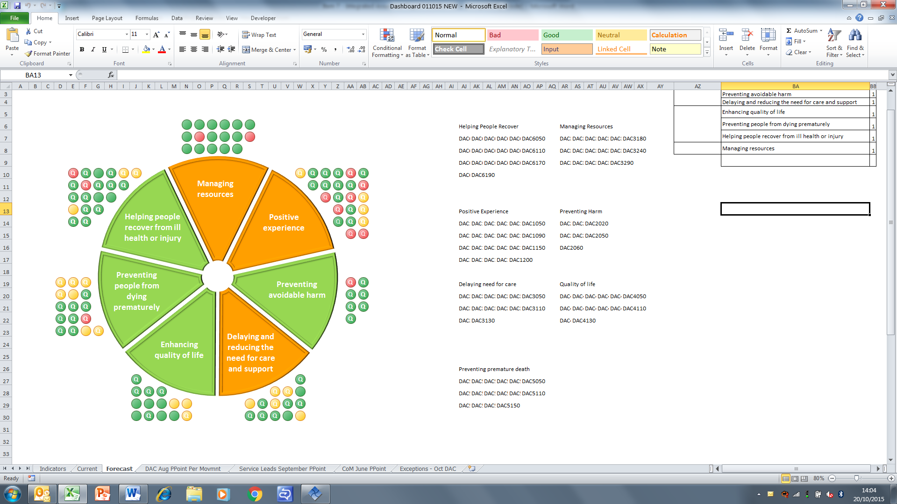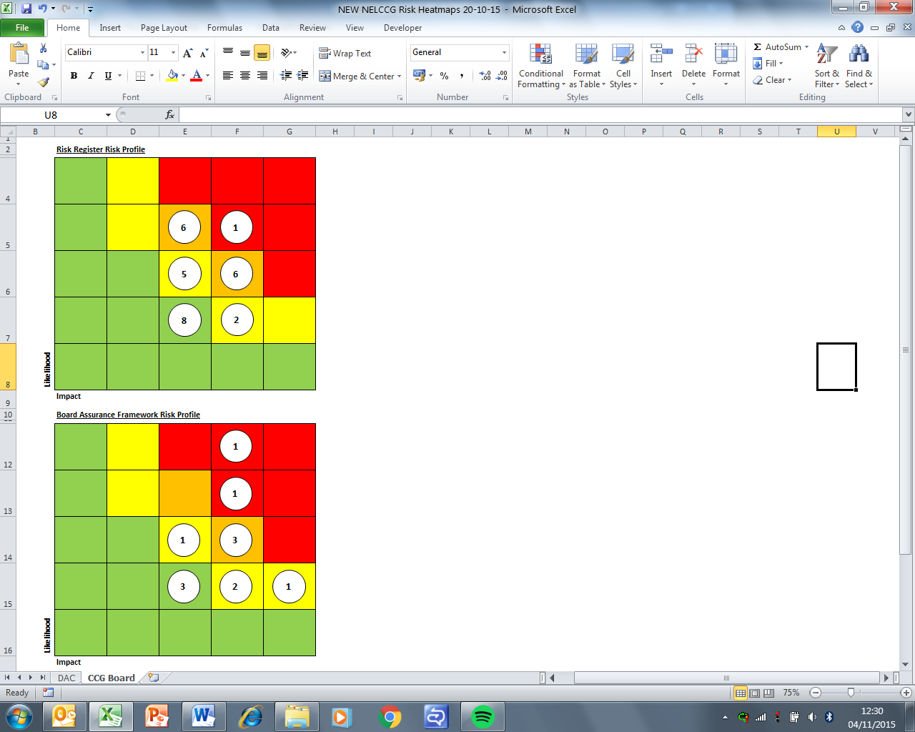

Please note the letter Q indicates a quality measure. These indicators focus on safety, experience and effectiveness and are present in the NHS England Quality Dashboard and the Quality domain of the CCG Assurance Framework.
Escalation

Performance Highlight

Cancer performance

Although the NHS Constitution focuses on waiting times in respect to performance the CCG monitors and assesses performance across a much wider spectrum when it comes to the pathway for patients with cancer. The summary below attempts to show how NHS North East Lincolnshire performs across the range of measures compared to the other 209 CCGs nationally as well as a select group of 20 other CCGs who share a similar demographic profile. Performance is better where NELCCG (yellow point) are closer to the outer edge of the diagram.

There are clearly areas where the CCG is performing worse than the national and peer average, notably across incidence, mortality and survival rates whereas the CCG performs better than the average for the other areas such as screening, waiting times, presentation and diagnosis.

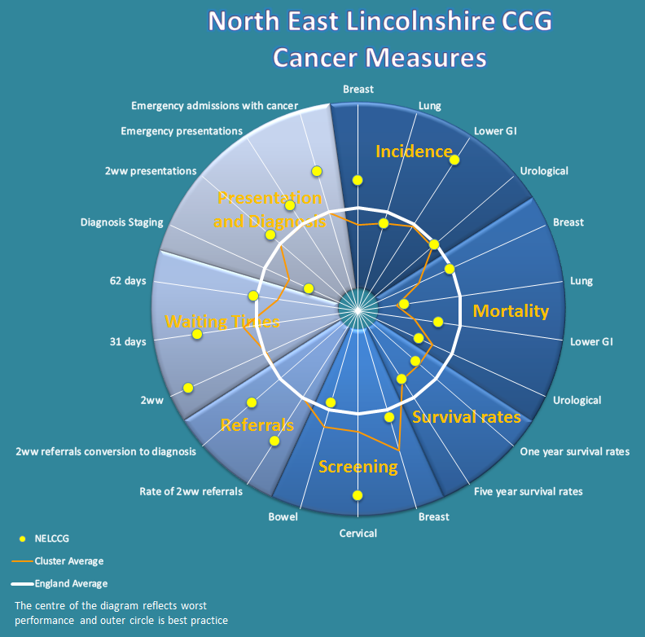
Appendix A - Performance Exception Summary
Code | Indicator | Quality Measure? | Latest period |  |  |  | 2015/16 year to date |  |  | Year End Forecast
Code | Indicator | Quality Measure? | Period | Target | Value | Status | Target | Value | Status | Year End Forecast
Positive experience
DAC1000 | Total time in A&E: four hours or less | Yes | August 2015 | 95% | 93.6% |  | 95% | 94.9%
DAC1040 | Numbers of unjustified mixed sex accommodation breaches | Yes | September 2015 | 0 | 0 |  | 0 | 4 | 
DAC1080 | Friends & Family - AAE % Who would recommend service | Yes | August 2015 | 88.43% | 86.81% |  | 88.1% | 84.23%
DAC1090 | Friends & Family - AAE Response (NLAG) | Yes | August 2015 | 14.29% | 13.33% |  | 14.81% | 13.11%
DAC1110 | Friends & Family - Inpatient Response (NLAG) | Yes | August 2015 | 25.55% | 18.35% |  | 27.03% | 19.8%
DAC1120 | Friends & Family - Outpatient - % Who would recommend service | Yes | August 2015 | 92.24% | 92.47% |  | 92.2% | 89.21%
DAC1130 | Friends & Family - Outpatient Response | Yes | August 2015 | 5% | 0.58% |  | 5.86% | 0.74%
DAC1150 | Friends & Family - Community Response (CPG) | Yes | August 2015 | 3.41% | 6.46% |  | 3.55% | 1.45%
DAC1180 | Friends & Family - Maternity - Combined % Who would recommend | Yes | August 2015 | 95.56% | 92.98% |  | 95.64% | 91.78%
DAC1190 | Friends & Family - Maternity Response (NLAG) Birth | Yes | August 2015 | 21.21% | 19.76% |  | 22.79% | 10.03%
DAC1200 | Friends and family test - Employee score | Yes | Q1 2015/16 | 77.89% | 50.31% |  | 77.89% | 50.31%
Preventing avoidable harm
DAC2000 | MRSA Blood Stream Infections | Yes | September 2015 | 0 | 0 |  | 0 | 2
Delaying and reducing the need for care and support
DAC3010 | Adult and older clients receiving a review as a percentage of those receiving a service. | Yes | September 2015 | 57.15% | 35.27% |  | 57.15% | 35.27%
DAC3020 | Outcome of short-term services: sequel to service | Yes | March 2015 | 68.06% | 67.71% |  | No data available for 2015-16
DAC3040 | Permanent admissions 65+ to residential and nursing care homes, per 100,000 population | No | September 2015 | 295.8 | 371.34 |  | 295.8 | 371.34
DAC3060 | Delayed transfers of care from hospital which are attributable to adult social care per 100,000 pop | Yes | August 2015 | 1.6 | 0.8 |  | 1.6 | 1.75
DAC3130 | The proportion of older people aged 65 and over offered reablement services following discharge from hospital. | No | March 2015 | 1.35% | 1.21% |  | No data available for 2015-16
Enhancing quality of life
DAC4070 | Proportion of adults with learning disabilities in paid employment | No | September 2015 | 5% | 3.5% |  | 5% | 3.5%
DAC4080 | Employment of people with long-term conditions | No | Q4 2014/15 | 13.1 | 10.1 |  | No data available for 2015-16
DAC4130 | End of life care – Percentage of all deaths that occur at home (including care homes) | Yes | Q4 2014/15 | 52% | 48.56% |  | No data available for 2015-16
Preventing people from dying prematurely
DAC5000 | Category A (RED1) calls meeting eight minute standard (EMAS) | Yes | September 2015 | 75.00% | 70.57% |  | 75.00% | 73.83%
DAC5010 | Category A (RED2) calls meeting eight minute standard (EMAS) | Yes | September 2015 | 75.00% | 66.16% |  | 75.00% | 70.64%
DAC5020 | Category A calls meeting 19 minute standard (EMAS) | Yes | September 2015 | 95% | 89.6% |  | 95% | 92%
DAC5030 | Category A calls meeting 19 minute standard (NELCCG) | Yes | September 2015 | 95% | 91.79% |  | 95% | 93.2%
DAC5040 | Ambulance 30 minute average turnaround time target - DPOW | No | September 2015 | 30 mins | 33.28 mins |  | 30 mins | 33.23 mins
DAC5110 | Cancer 62 Days Referral to Treatment (GP Referral) | Yes | August 2015 | 85% | 81.08% |  | 85% | 79.01%
DAC5140 | The rate of people admitted with a primary diagnosis of hip fracture per 100,000 CCG population | No | December 2014 | 431.5 | 469.2 |  | No data available for 2015-16
DAC5150 | Summary Hospital Mortality Index (SHMI) - NLAG | Yes | December 2014 | 100 | 109.8 |  | No data available for 2015-16
Helping people recover from ill health or injury
DAC6000 | Total Emergency admissions for acute conditions that should not usually require hospital admission | Yes | August 2015 | 159 | 192 |  | 842 | 993
DAC6040 | 18 week referral to treatment times - admitted patients (CCG Total) | Yes | August 2015 | 90% | 84.98% |  | 90% | 86.07%
DAC6050 | 18 week referral to treatment times - non-admitted patients (CCG Total) | Yes | August 2015 | 95% | 94.33% |  | 95% | 94.93%
DAC6070 | RTT - Number waiting on an incomplete pathway over 52 wks | Yes | August 2015 | 0 | 0 |  | 0 | 1
DAC6150 | Readmissions to mental health services < 30 days | No | Q4 2014/15 | 100.0 | 154.2 |  | No data available for 2015-16
Managing resources
DAC3200 | Non-Elective Activity (General & Acute) | No | August 2015 | 1595 | 1314 |  | 7919 | 6592
DAC3240 | A&E Attendances (NEL Patients) | No | August 2015 | 4461 | 4683 |  | 22185 | 23784
Appendix B - Risk Exception Summary

The table below reflects risks rated as 16+ (high to significant) on the risk register as at 18 August 2015

No. | Risk | Current risk rating | Risk Lead | Internal Controls | Latest update
1 | CCG2002  On-going failure to meet Clinical Handover time targets for EMAS patient delivery at DPoW A&E | 16 | Andy Ombler | Moving from monitoring only to action planning  Performance is monitored by the Urgent Care Board. | Andy Ombler - risk reviewed and updated 16 October 2015 as follows:  Performance for September improved from August and on average remains better than the overall contract average. The key measures to support handover improvement remain as described in the August update and these remain in progress for deployment with progress being reported through the NEL SRG  August update:  Handover performance remains around 3 minutes above the target at DPoW though slightly below the average all hospitals in the EMAS contract.  The planned new arrival screen initiative remains scheduled for October. This will change the way all handover timings are recorded with a dual “sign-off” process required at each stage and will enable handover performance discussions to be based on an agreed methodology.

The table below reflects risks rated as 15+ (high to significant) on the assurance framework as at 16 October 2015

No. | Risk | Current risk rating | Risk Lead | Internal Controls | Latest Update
1 | CCGAF4001  Risk that Healthy Lives, Healthy Futures will not deliver the quality and financial sustainability outcomes in the requisite timeframe | 16 | Lisa Hilder | - Further work on reviewing and refreshing the financial gap has been commissioned by the Programme Board to be delivered by PWC (13 October 2014)  - HLHF Programme Board  - Governance framework provided by HLHF programme board, engagement core group and assurance sub group in place.  The HLHF Programme Board reviews progress monthly towards financial and clinical sustainability goals for Northern Lincolnshire. The Programme Board reviews the programme risk log on a monthly basis and has also established an assurance sub group to identify key areas of concern and recommend remedial action. With regards to financial sustainability the Executive group of the Programme board meets weekly virtually and receives ongoing reports & assurance on updated position. | Lisa Hilder - risk reviewed 8 October 2015, no change since the last update as at 17 August 2015:  Clinical workshops have identified key workstreams:  Planned care  Unplanned care  Women and children  Long term conditions  These are being grouped into in hospital and out of hospital care, with initial focus on out of hospital care. The Programme Board have received an outline strategy for service redesign which is currently being refined. Further communications and engagement where relevant to support outline changes will take place during the latter part of 2015/16
2 | CCGAF3002  Risk CCG could face financial challenges (i.e. Fail to deliver a balanced budget or funding gap) & does not achieve statutory financial obligations. Particular issue due to ASC funding pressures, local NHS community financial challenges, & acute provider deficit | 20 | Cathy Kennedy | Within the CCG the Integrated Governance and Audit Committee assures management of financial risk  Regular meetings for Executive Directors for CCG/LA to monitor position.  HLHF programme arrangements include Memorandum of Understanding including a collective risk management approach | Cathy Kennedy - risk reviewed 7 October 2015 and no changes noted at this time

