Integrated Assurance Report

Introduction

The dashboards below represent an overview of performance and risk for health and social care services across North East Lincolnshire.

The performance dashboard consists of seven domains that incorporate all areas that North East Lincolnshire Clinical Commissioning Group strive to improve on. A judgement has been made of the status for each domain based on the performance measures underpinning them. These judgements try to balance the current position with the expected outcome at the end of the year and weightings with respect to priority. They also represent the local perspective of performance for North East Lincolnshire rather than the performance against the national definition which, on occasion, covers a broader footprint. It should be noted that those issues that have an impact on the CCGs corporate performance assessment will continue to be scrutinised at the Delivery Assurance Committee. The Delivery Assurance Committee is asked to make a decision on the final status of the dashboard before reporting to the CCG Partnership Board. The risk dashboards are separated in to a CCG risk register and the CCGs Board Assurance Framework risks. These dashboards demonstrate the number of risks with a specific risk score. The performance dashboard reflects performance for the first two months of 2015-16 and the risk summaries reflect risk status as at 15th June 2015. Full exception report summaries are also included for Performance (appendix A) detailing performance of indicators that are underperforming and risk (appendix B) detailing risks rated as 16 or higher.

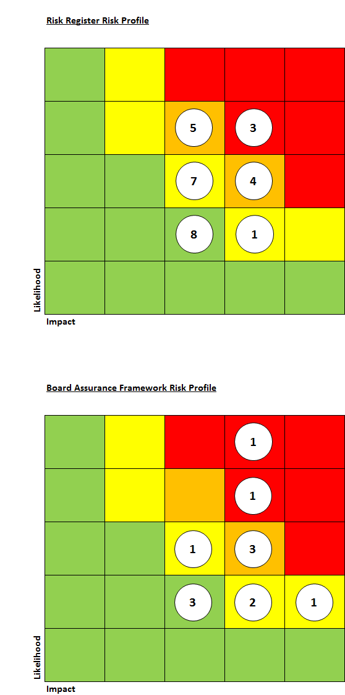
Performance Dashboard
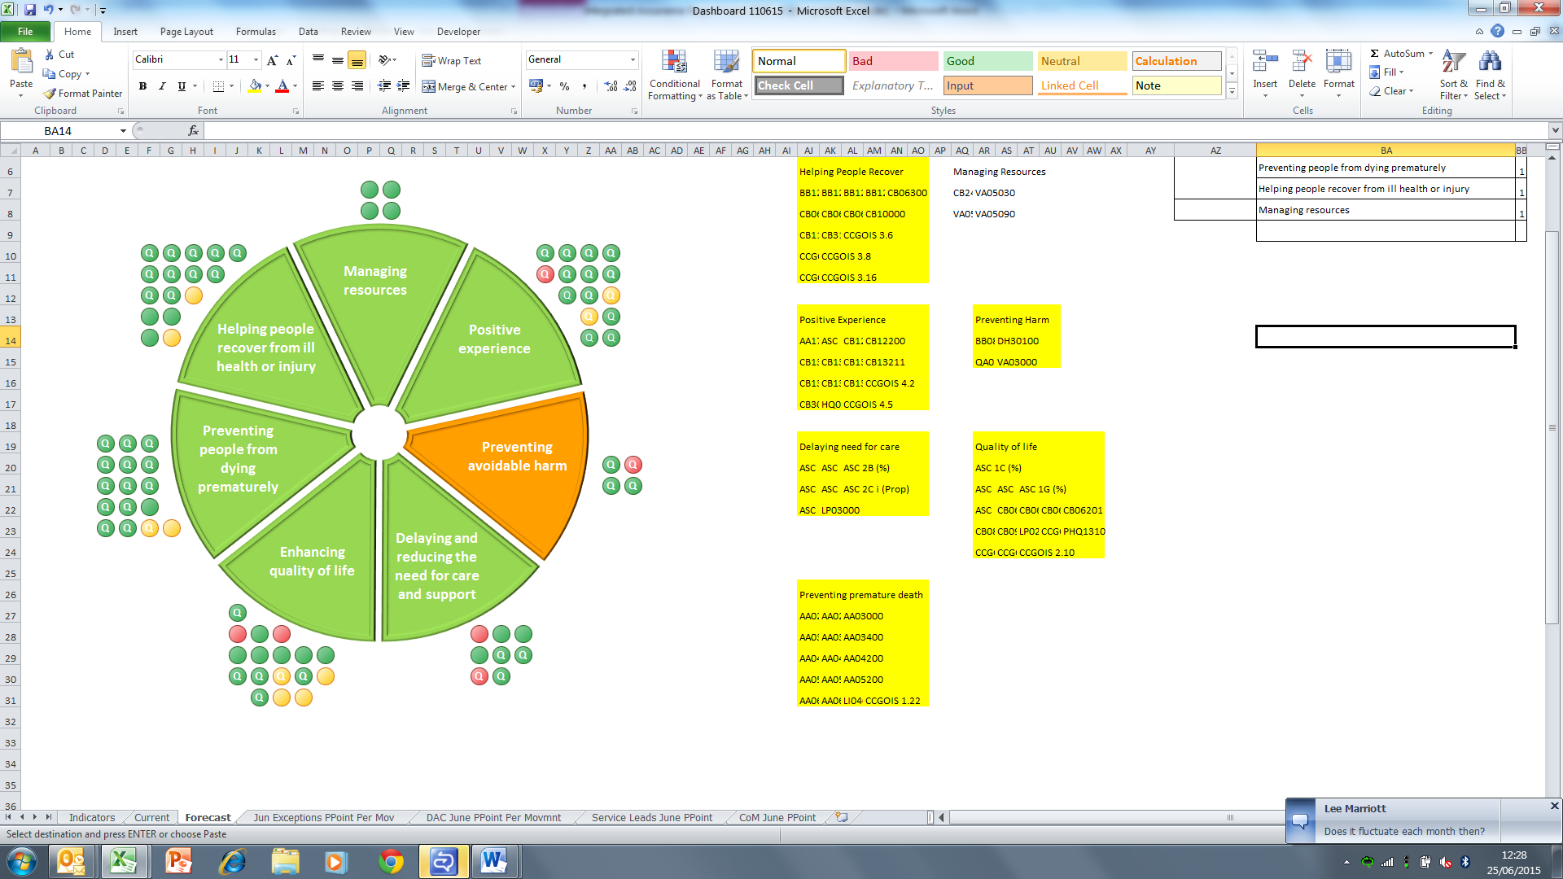

Please note the letter Q indicates a quality measure. These indicators focus on safety, experience and effectiveness and are present in the NHS England Quality Dashboard and the Quality domain of the CCG Assurance Framework.
Escalation

Performance Highlight

‘Avoidable emergency admissions’

The CCG Outcomes Indicator Set contains a measure that focuses on emergency admissions where the diagnosis suggests that the admission was ‘avoidable’.

It is a composite measure which includes one that centres on conditions that should usually be managed without the patient having to be admitted to hospital. These conditions include, for example, ear/nose/throat infections, kidney/urinary tract infections and heart failure.

It is clear from the chart below that the CCG has seen continuous growth in this area over the last five years and further analysis shows that the growth is being driven by three main types of diagnoses which include kidney/urinary tract infections, influenza/pneumonia and cellulitis. With the three highest levels of admission occurring in the last eight months this is clearly an area the CCG need to focus on. Further work is currently being undertaken to understand some key links between this and other potential influential factors.
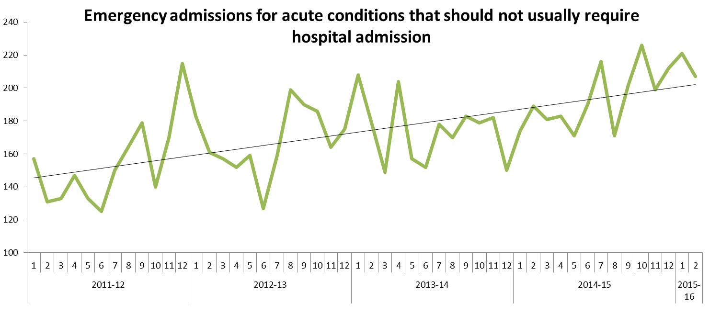
There is a further measure that focuses on patients who have long term conditions which should not normally require hospitalisation known as ‘Chronic Ambulatory Care Sensitive Conditions’ (CACSC). These conditions include, for example, diabetes, epilepsy and high blood pressure.

In contrast to the first measure we can see from the chart below that although the CCG saw a rise in these admissions between April 2011 and March 2013 it has since seen a steady reduction over the following 26 months. The reduction has been seen across many of the conditions but most notably for Angina. It should be noted however, that admissions for patients with COPD, continues to rise.

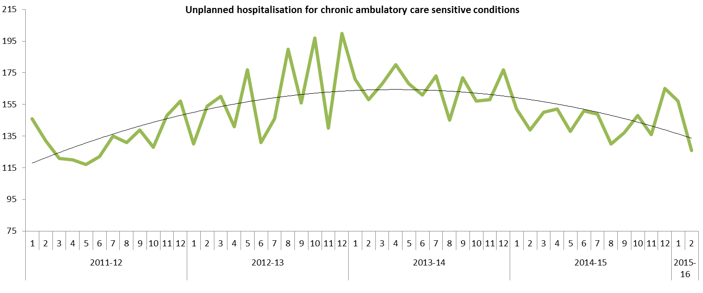
Appendix A - Performance Exception Summary
Code | Indicator | Quality Measure? | Latest period |  |  |  | 2015/16 year to date |  |  | Year End Forecast
Code | Indicator | Quality Measure? | Period | Target | Value | Status | Target | Value | Status | Year End Forecast
Positive experience
CB13205 | Friends & Family - Maternity Response Birth (NLAG) | Yes | April 2015 | 23.57% | 10.06% |  | 23.57% | 10.06%
CCGOIS 4.2 | Patient experience of hospital care | Yes | 2013/14 | 78.63 | 76.1 |  | No data available for 2015-16
Preventing avoidable harm
DH30100 | MRSA Blood Stream Infections | Yes | May 2015 | 0 | 1 |  | 0 | 2
Delaying and reducing the need for care and support
ASC 2A i (Prop) | Permanent admissions 18-64 to residential and nursing care homes, per 100,000 population | No | March 2015 | 9.39 | 13.60 |  | No data available for 2015-16
ASC LOC1 (%) | Adult and older clients receiving a review as a percentage of those receiving a service. | Yes | March 2015 | 85.00% | 73.70% |  | No data available for 2015-16
Enhancing quality of life
ASC 1E (%) | Proportion of adults with learning disabilities in paid employment | No | March 2015 | 11.00% | 1.90% |  | No data available for 2015-16
ASC 1G (%) | Proportion of adults with learning disabilities who live in their own home or with their family | No | March 2015 | 79.90% | 66.60% |  | No data available for 2015-16
CCGOIS 2.9 | Access to community mental health services by people from Black and Minority Ethnic (BME) groups | No | 2013/14 | 2035.9 | 1430.3 |  | No data available for 2015-16
CCGOIS 2.10 | Access to psychological therapies services by people from Black and Minority Ethnic (BME) groups | No | 2013/14 | 719.4 | 286.1 |  | No data available for 2015-16
LP02000 | Deaths that occur at home (inc. care homes) | Yes | Q2 2014/15 | 50.5% | 49.1% |  | No data available for 2015-16
PHQ1310 | % people who have depression and/or anxiety disorders who receive psychological therapies | No | Q3 2014/15 | 2.5% | 2.6% |  | No data available for 2015-16
Preventing people from dying prematurely
CCGOIS 1.22 | The rate of people admitted with a primary diagnosis of hip fracture per 100,000 CCG population | No | June 2014 | 421.3 | 438.9 |  | No data available for 2015-16
LIO4000 | Summary Hospital Mortality Index (SHMI) – NLAG | Yes | September 2014 | 100 | 110.3 |  | No data available for 2015-16
Helping people recover from ill health or injury
CCGOIS 3.6 | People who have had an acute stroke who receive thrombolysis | No | 2013/14 | 11.6% | 7.1% |  | No data available for 2015-16
CCGOIS 3.16 | Readmissions to mental health services within 30 days of discharge | No | 2013/14 | 100.0 | 171.9 |  | No data available for 2015-16
Appendix B - Risk Exception Summary

The table below reflects risks rated as 16+ (high to significant) on the risk register as at 15 June 2015

No. | Risk | Current risk rating | Risk Lead | Internal Controls | Latest update
1 | CCG3012  18 week RTT performance | 16 | Debbee Walker | Commissioning action plan is in place which is reported through Delivery Assurance Committee for progress.  Updates fed into internal Groups for information/further discussion and action: Service Leads, Council Of Members, System Resilience Group.  Clinically led collaborative meeting with Providers to discuss service delivery concerns/ improvements.  Financial penalties imposed on Providers for non-achievement of Key Performance Indicators. | Debbee Walker - risk reviewed and updated 1 June 2015  Risk remains high, however NLAG assured the CCG at the System Resilience Group on the 1 June 2015 that their performance for all 3 pathways will achieve target by June 2015.
2 | CCG1003  Failure to achieve Accident and Emergency 4 hour targets | 16 | Andy Ombler | Commissioning weekly monitoring of performance. System Resilience Group jointly focussed on performance group includes NL&G intermediate Care and commissioners. Action Plans focussing on all issues with potential impact on 4 hour A&E wait performance. SRG action plan in place. | Andy Ombler - risk reviewed and updated 15 June 2015  The improvement noted in April continued throughout May leading to an average performance above the 95% specification for the whole month. A number of bed capacity alerts were issued at the beginning of June as admission activity increased and June performance remains at or about 95%. The risk rating reduced from 20 to 16
3 | CCG1004  On-going failure to meet Clinical Handover time targets for EMAS patient delivery at DPoW A&E | 16 | Andy Ombler | Moving from monitoring only to action planning  Performance is monitored by the Urgent Care Board. | Andy Ombler - risk reviewed and updated 15 June 2015  The May dataset has been delayed so cannot yet comment on performance compared to April.  YTD performance is 31.26 against target of 30 mins. Performance for the last 3 months has been above the target of 30 mins and the target is not met for the full year.  The rise in handover times is aligned directly with the increase in both conveyance rate/pressures in the DPoW A&E department and A&E performance and as such is expected to improve in line with A&E performance improvement. Resilience planning for 2015/16 will determine if any additional measures are required on operational interaction between EMAS and DPoW A&E separate from overall resilience measures that aim to support the whole system under times of surge and escalation

The table below reflects risks rated as 15+ (high to significant) on the assurance framework as at 15 June 2015

No. | Risk | Current risk rating | Risk Lead | Internal Controls | Latest Update
1 | CCGAF3003 - Risk that Healthy Lives, Healthy Futures will not deliver the quality and financial sustainability outcomes in the requisite timeframe | 16 | Lisa Hilder | Further work on reviewing and refreshing the financial gap has been commissioned by the Programme Board delivered by PWC 13/10/14.  Governance framework provided by HLHF programme board, engagement core group and assurance sub group in place.  The HLHF Programme Board reviews progress monthly towards financial and clinical sustainability goals for Northern Lincolnshire. The Programme Board reviews the programme risk log on a monthly basis and has also established an assurance sub group to identify key areas of concern and recommend remedial action. With regards to financial sustainability the Executive group of the Programme board meets weekly virtually & receives ongoing reports & assurance on the updated position. | Lisa Hilder - risk reviewed and updated 5 June 2015  Clinical workshops have identified key workstreams:  - Planned care  - Unplanned care  - Women and children  - Long term conditions  These are being grouped into in hospital and out of hospital care, with initial focus on out of hospital care  The programme Board have received an outline strategy for service redesign which is currently being refined.  Further communications and engagement where relevant to support outline changes will take place during 2015
2 | CCGAF3008 - Risk CCG could face financial challenges (i.e. Fail to deliver a balanced budget or funding gap) and therefore does not achieve statutory financial obligations. Particularly at this time due to NELC (ASC) funding pressures, local NHS community financial challenges, & acute provider deficit | 16 | Cathy Kennedy | Within the CCG the Integrated Governance and Audit Committee assures management of financial risk  Regular meetings for Executive Directors for CCG/LA to monitor position.  HLHF programme arrangements | Cathy Kennedy - risk reviewed and update 5 June 2015 as follows:  Narratives amended and risk rating increased from 16 to 20.

