Healthy Lives, Healthy Futures Update
Issue 1, August 2016
North Lincolnshire CCG  North East Lincolnshire CCG  Northern Lincolnshire and Goole NHS Foundation Trust  Rotherham, Doncaster and South Humber NHS Foundation Trust | North Lincolnshire Council  North East Lincolnshire Council  Navigo  Care Plus Group  focus Independent Adult Social Work

Health organisations and Local Authorities in North and North East Lincolnshire working together to transform our health and care system

Welcome to the first of what will be a regular update from the Healthy Lives, Healthy Futures team
Background
The Health Organisations and Local Authorities in North and North East Lincolnshire continue to work together to transform the health and care system through the Healthy Lives Healthy Futures Programme. In March 2016, leaders from all organisations agreed the approach for the next phase. This has seen a number of changes to the supporting governance to ensure they are fit for purpose.
There has been some debate and discussion about whether we should continue to use Healthy Lives Healthy Futures (HLHF) as our banner and we have now confirmed that we will still use that banner for the programme, being clear we are moving into the next phase.
The approach agreed is being referred to as ‘Option 4’, reflecting;
- The development of two place based Accountable Care Partnerships in North Lincolnshire and North East Lincolnshire, which comprise of providers from acute, mental health, primary and community care settings to take forward the transformation of place based health and care
- ‘At scale’ programme which is about taking forward those services which need to be planned and delivered for a population size greater than at an individual place level and will link with the Humber, Coast and Vale Sustainability and Transformation Plan (STP)
- HLHF System Board – coordinating the transition and delivery of all elements

Leadership for the programme comes from across the health and care system
Ian Atkinson (previously Chief Officer at Sheffield CCG and previous chair of the HLHF Assurance Group) has been appointed as Independent System Chair and will chair the System Board.
Caroline Briggs has been seconded from her role as Director of Commissioning in North Lincolnshire CCG as Programme Director from the 1st July.
The leadership team for the programme - Senior Responsible Officers (SROs) for each element are:
Accountable Care Partnerships (ACP)
Dr Pav Tandon (Chair of Safecare GP Federation) for North Lincolnshire
Jane Miller (Chief Executive Care Plus Group) for North East Lincolnshire

At Scale
Karen Jackson (Chief Executive Northern Lincolnshire and Goole Foundation Trust) will chair the Services At Scale group as lead for the STP Acute and specialised workstream
Joint Strategic Commissioning
Liane Langdon (Chief Officer North Lincolnshire CCG) will chair the Joint Strategic Commissioning Forum

Timescales
In signing off the approach in March, leaders set the following timescales:

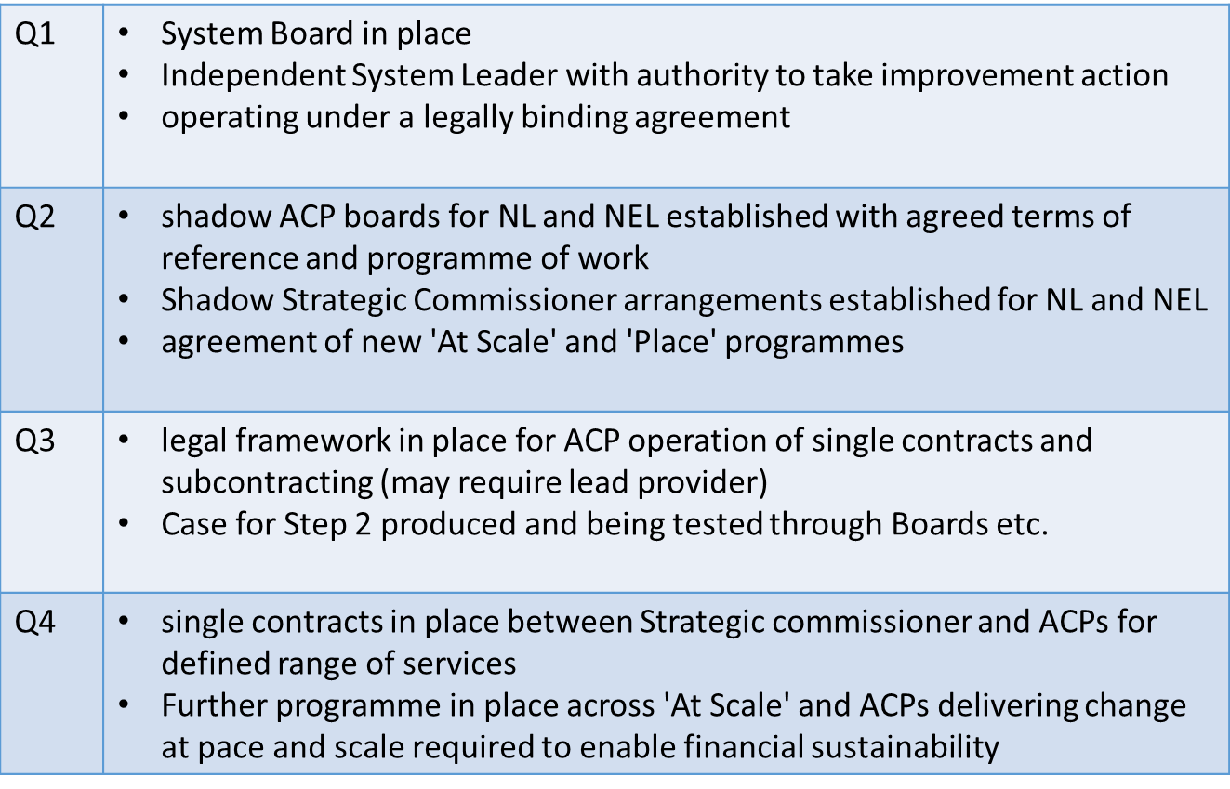

Progress to date
Q1 - 2016
- Ian Atkinson was appointed in April
- Leadership team to support identified as above
- The first meeting of the System Board took place on the 14th June with a focus on the current HLHF schemes and where the leadership to deliver them will sit, along with revised governance arrangements. This included considering draft Terms of Reference for the key groups going forward (System Board, Strategic Commissioners and Services At Scale), these are now being finalised. Updates were also received from both developing ACPs.
- Shadow ACPs have been established in both North and North East Lincolnshire and have been meeting regularly from April to establish relationships, initial governance, leadership and support arrangements and begin to identify priorities within their work plans
- A review of schemes within the HLHF community plan to assess the current position re delivery undertaken with each SRO

Q2 – July 2016
- Joint Strategic Commissioning Forum met and pulling together work plan
- Planning meeting for At Scale Group taken place and work plan being developed
- System Board met for second time on the 28 July and has
  - Confirmed Terms of Reference for System Board, At Scale Group, Joint Strategic Commissioning Forum
  - Considered and is finalising the proposed support arrangements and programme budget
  - Discussed the assessment of progress in relation to current plans. Schemes have been assessed against the following definitions:
    - BLUE - LIVE – being implemented, there is no further action required and these can deliver as intended and realise the benefits in their plans.
    - GREEN - Implementable - it is evidence based, worked up and there is an agreed implementation plan, with impact metrics. It has been agreed whether the scheme will be delivered “at scale” or through ACPs locally.
    - AMBER - Requires agreement to be implemented - A proposed scheme exists, it is evidence based and a proposal exists, with impact metrics for how this service will be enhanced through either the ACP arrangement or “at scale” but there is no agreed implementation plan for it.
    - RED - Requires work up - A proposal exists but there is no clear evidence base or work up of how the ACP or at scale delivery can enhance the service or re-design it and there has been no assessment of whether it would be better delivered at scale, or agreement to it being delivered at scale.
  - Considered the update from STP plans and identified the expectation that the full impact will be understood by October.

Next Steps

- During the remainder of Q2 the revision of governance will be formally completed including establishing the calendar of meetings for the year
- Finalisation of programme management support
- At Scale and ACPs programmes to be fully agreed taking account of the impacts and opportunities presented by the STP.
- Development of programme reporting including a review of risks
- Regular briefings are proposed to follow each System Board meeting which will be available to all partners to update Governing Bodies, Boards and Management Teams and to be made publically available.

Need further information?
For further information about Healthy Lives, Healthy Futures, please contact the Programme Office by emailing nlccg.hlhf@nhs.net

