Medicines Optimisation

Point of Dispensing Intervention Service (PODIS) CCG recommendation report

Document Summary
Directorate: | Medicines Optimisation
Document Purpose: | To review the current PODIS Scheme
Document Name: | Point of Dispensing Intervention Service (PODIS) CCG recommendation report
Document Ref No.
Author: | Vasiliki Kelidou
Report Owner or Sponsor:
Target Audience: | North East Lincolnshire CCG
Description
Superseded Document: | None
Action Required: | Decision on which recommendation to implement for PODIS scheme
Contact Details  (for further information and feedback) | Name & Title: Vasiliki Kelidou  Tel: 07423628592  E-mail: Vasiliki.kelidou@nhs.net
Document Status
This is a controlled document. Whilst this document may be printed, the electronic version posted on the intranet is the controlled copy. Any printed copies of this document are not controlled.
As a controlled document, this document should not be saved onto local or network drives but should always be accessed from the intranet.

Version | Date | Summary | Owner’s Name | Approved
1
2
3

Table of Contents

Document Summary………………………………………………………….………….…. 2

Title of Report: Point of Dispensing Intervention Service (PODIS) CCG
Recommendation report………………………………………………………..............…. 4
1. Purpose of the report……………………………….………………………………….... 4
1.1. Background………………………………………………………………………..… 4
1.2. Objectives and scope of the report………………………………………………...4
1.3. Key points………………………………………………………………………….….4
1.4. Target Audience……………………………………………………………………...4
2. Introduction…………………………………………………………………………..........4
2.1 Aims and Objectives……………………………………………………...................5
2.2 Service Specification……………………………………………………………….....5

3. Contract Performance…………………………………………………………..….…......6

3.1 Age groups interaction……………………………………………………..…….......6

3.2 Analysis of GP practices…………………………………………….…………..…...7

3.2.1 Patients per GP surgery using PODIS scheme……………………..…….....7

3.2.2 Electronic Repeat Dispensing……………………………………..……….…..8

3.3 Analysis of Prescription Type of items stopped……………………….……….….9

3.4 Analysis of Intervention Reason……………………………………………………10

3.5 Signposted patients………………………………………………………………….10

3.6 Financial Summary……………………………………………………………….....11
4. Options……………………………………………………………………………….…….11
4.1 Review options……………………………………………………………………….11
Recommendation
The Medicine Optimisation Team recommends option one until March 2022 with a potential review into option two. The rationale for this recommendation is PODIS scheme adds value on patients’ health outcomes while generating savings without incurring additional costs apart from the annual license fee of the PharmOutcomes platform……………………………………………………………………………………......12
APPENDIX 1.GP practice data for PODIS patient involvement………………………...14

Title of Report: Point of Dispensing Intervention Service (PODIS)

CCG recommendation report.

Purpose of the report

Background
The Point of Dispensing Intervention Service (PODIS), identified and performed by community pharmacists, contributes to the reduction of prescribed unwanted medicines, which are currently wasted. By also informing GP repeat prescribing processes, it aims to contribute to improved patient outcomes through harm reduction, reduced hospital admissions, and increased medicine concordance. Even though the service is relatively new, the data has shown savings with potential for growth. Unfortunately, due to the current COVID-19 pandemic and the fact that community pharmacies are experiencing unprecedented pressure, the utilisation of PODIS has been reduced. It is important to note that its discontinuation may result in an increase in prescribed medicines wastage.
There are three possibilities, which could be considered; the purpose of this document is to highlight these options and approve a recommendation regarding the Point of Dispensing Intervention Service (PODIS).

Objectives and scope of the report

The scope of this document is to provide information on the PODIS scheme and examine the recommendations identified.

Key points
- Review PODIS scheme
- Review PODIS scheme continuation options
- Gain approval for recommended PODIS Scheme

Target Audience
The target audience for this document is North East Lincolnshire CCG.

Introduction
2.1 Aims and Objectives
PODIS is a community pharmacy enhanced service, which is commissioned by NHS England on behalf of local CCGs. The main objective of the scheme is to reduce the burden of waste medicines, which impacts the patients’ risk of harm, hence influencing patients’ health outcomes, as well as having serious financial implications.

The PODIS scheme aims to reduce the burden of waste medicines by:

- Reducing the number of unwanted medicines dispensed and therefore wasted, by not dispensing items not required by the patient.
- Notifying the prescriber when an item prescribed has not been dispensed.
- Promoting, supporting and encouraging good repeat / prescribing practices with patients and GP practices.
- Reducing unnecessary prescribing costs.
2.2 Service Specification
North East Lincolnshire CCG currently has 28 Community Pharmacies of which 17 are currently commissioned to deliver the PODIS scheme.
The current PODIS scheme in North East Lincolnshire CCG is as follows:

- The pharmacy will at the point of handing out a completed prescription to a patient (or their representative where the patient has consented to the representative acting in this capacity) discuss with the patient the contents of the completed prescription and whether each item as dispensed is required by the patient.

- Where, as a result of the discussion described above, an item that has been ordered on the prescription is identified as not being required by the patient, the pharmacy will, at the discretion of the pharmacist, make an intervention to not dispense the item.

- When the pharmacist makes an intervention as described above, they will notify the patient’s GP that they have made that intervention and the reason why the item was not required. (This will be normally be done automatically by the PharmOutcomes system, but may sometimes require the pharmacy to post the notification).

- When the pharmacist makes an intervention, that in their discretion may be clinically significant to the patients continuing treatment, they will deliver a Medicines Use Review to support the patients’ safe use of the prescribed medicines.

- Where a pharmacy makes an intervention they should check the patient history on PharmOutcomes to see if the patient has received a similar intervention in the previous period of treatment for the same item. If there has been a previous intervention the pharmacy should record this in the PharmOutcomes record and if appropriate, deliver a Medicines Use Review to the patient.

- Where a pharmacy makes an intervention, on an item that is prescribed on a paper prescription form, they shall score through the item so as to make it illegible.

- Where a pharmacy makes an intervention, on an item that is prescribed through the Electronic Prescription Service, they endorse the item as Not Dispensed (ND) on the Electronic Prescription Service claim.

- The pharmacy staff will ensure that the service is explained to the patient at the outset. This explanation will include the reasoning for the service. They must re-assure any patient anxious about having an item not dispensed this time and that it does not mean it has been automatically removed from the repeat prescription.
3. Contract Performance
3.1 Age groups interaction

The pharmacy inputs the number and details of consultations undertaken into PharmOutcomes. This is used to generate monthly reports showing activity and cost data. The data below is for the financial year April 2019 to March 2020.

The number of Provisions/Personal Interactions during the financial year that is examined was 1341 while the patients identified count to 1075.

By looking the graph below showing the age group specific interaction for the provision of the PODIS scheme, it is evident that the elderly population (65y and over) that is mostly affected by polypharmacy problems, account for the 48% of the patients that have been identified and used the service.

Age group related service interaction (PharmOutcomes Report 2019/2020).

3.2 Analysis of GP practices

3.2.1 Patients per GP surgery using PODIS scheme

The specific graph shows the patients used the service categorised by the GP surgery. This data can be used to identify area population that has benefitted from the service as well as identify further needs that can be addressed with individual practices. The raw data can be found in the Appendix 1. GP practice data for PODIS patient involvement.

Patient involvement in PODIS scheme per individual practice.

3.2.2 Electronic Repeat Dispensing

Electronic Repeat Dispensing (eRD) is expected to negate the need for PODIS. The utilisation of eRD has increased this year but could still remains low in some practices. The first graph below shows the percentage of the electronic repeat dispensing items by practice in North East Lincolnshire and how they compare to the CCG average. The second graph shows the percentage of electronic repeat dispensing patients per practice in North East Lincolnshire.

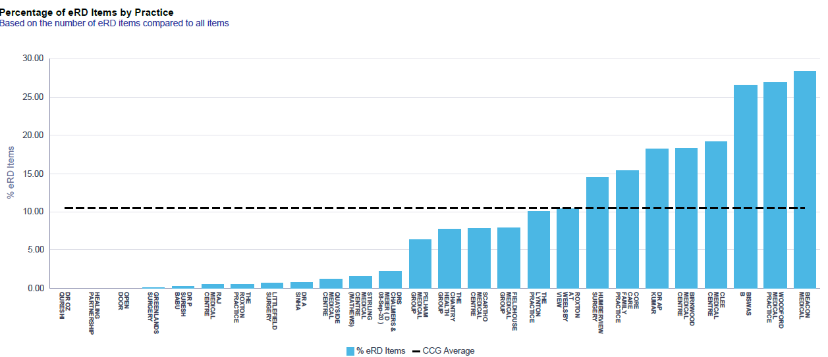
Percentage of the electronic repeat dispensing items by practice.
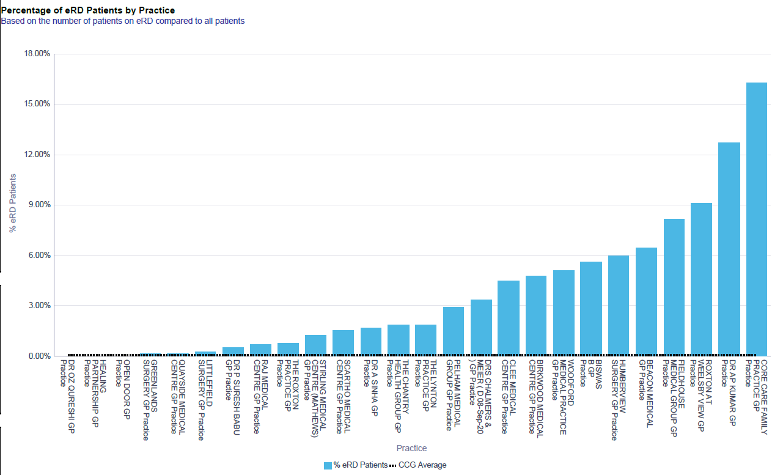

Percentage of electronic repeat dispensing patients per practice.

3.3 Analysis of Prescription Type of items stopped

According to the table and graph below, it is is evident that even though the expectation is that the managed repeat system creates the majority of waste medicines, the data shows that it contributes to less than 20%. This raises the issue that even if the managed repeat system is stopped, the change is still not as impactful. However, by using PODIS scheme, waste medicines can be identified with any type of prescription, especially the repeat prescriptions that account for the biggest part of the waste of medicines.

Prescription Type Total
Green paper script - Acute | 39 (2.9%)
Green paper script - Repeat | 63 (4.7%)
Green paper script - PCS | 32 (2.4%)
Green paper script - Managed | 12 (0.9%)
EPS - Acute | 107 (8%)
EPS - Repeat | 863 (64.4%)
EPS - Managed | 225 (16.8%)
eRD service | 0 (0%)

Types of prescriptions with items stopped as a result of PODIS scheme.

3.4 Analysis of Intervention Reason

The intervention reasons for prescription items table and graph have interesting information to be discussed. As it is evident, the majority of unnecessary prescription issuing happens within GP surgeries without the patient or the community pharmacy ordering it. Another significant reason is that patients’ have plenty of prescription items at home but the prescription is still issued. Finally, two impactful reasons as shown are medication prescription has changed since the script was issued and item has been stopped by primary or secondary care but still issued. Therefore, PODIS scheme can allow community pharmacists to intervene and share the information via the platform with primary care so mistakes can be prevented in the future.

Intervention Reasons Total
Patient/representative - ordered in  error | 115 (8.6%)
Patient/representative - medication changed since script issued | 198 (14.8%)
Patient/representative - has plenty at home | 271 (20.2%)
Pharmacy - ordered item on behalf of patient in error | 38 (2.8%)
GP Surgery - Sent item in error that was not ordered | 351 (26.2%)
GP Surgery - duplicated item in error | 67 (5%)
GP Surgery - wrong item sent | 102 (7.6%)
GP Surgery - item has been stopped by GP/hospital/prescriber but script still issued | 199(14.8%)

Intervention reasons for prescription items.

3.5 Signposted patients

During the period of April 2019 to March 2020 the 97.1% of patients that have benefitted by PODIS scheme did not require to be further signposted to a healthcare professional for a review of the medication been stopped. Only a small 2.9% of patients had to be signposted further, information that shows a clear benefit for the patient and primary care.

Signposting of patients after PODIS scheme medication intervention.

3.6 Financial Summary

A professional fee of £4 is paid for each point of dispensing intervention made. In addition to the professional fee a payment equivalent to 10% of the net ingredient cost of the product not dispensed is made.

The table below shows the PODIS scheme target, the actual savings been made and the financial difference from April 2019 to March 2020. The actual savings reached £10,884.45 against £12,000 which was the set target. The numbers show a drop between December and March, with March thought to have been affected by the COVID-19 pandemic.

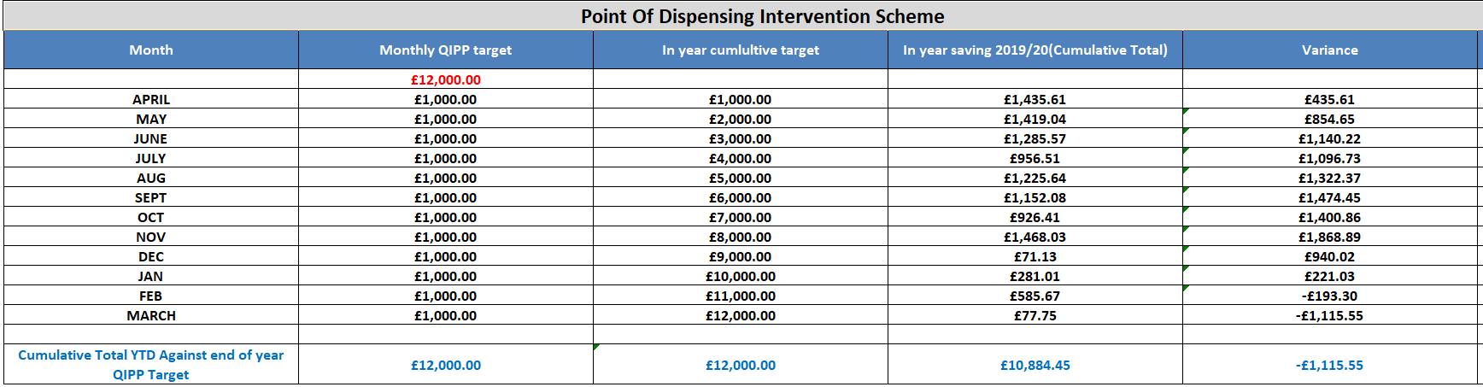

4. Options

4.1 Review options
There are three options to be considered as part of the recommendation.
Option 1
Extend in current format i.e. to continue with the scheme as it is until March 2022 as the contract expires on the 31st March 2021. This option will allow community pharmacists to add value to patients and help the unnecessary referrals to primary care especially this difficult period of time. The savings that will be generated from the service will also be an important factor. This period will help establish the true impact of PODIS and look potentially into option two.
Option 2
Renew the PODIS contract for another four years from March 2021 to March 2025. This may be an option but it is anticipated that as utilisation of electronic repeat dispensing is increased, the usefulness of PODIS will be reduced.
Option 3
Terminate PODIS giving three months’ notice as per service level agreement.

Recommendation

The Medicine Optimisation Team recommends option one until March 2022 with a potential review into option two. The rationale for this recommendation is PODIS scheme adds value on patients’ health outcomes while generating savings without incurring additional costs apart from the annual license fee of the PharmOutcomes platform.
APPENDIX
1. GP practice data for PODIS patient involvement
Scartho Medical Centre | B81030 | 216
Clee Medical Centre | B81015 | 138
Fieldhouse Medical Group | B81031 | 99
Blundell Park Surgery | B81620 | 86
Pelham Medical Group | B81016 | 78
The Lynton Practice | B81055 | 73
Open Door Surgery | Y01948 | 68
The Roxton Practice | B81039 | 66
Taylors Ave. Med. Centre | B81642 | 50
Roxton at Weelsby View | B81603 | 39
Birkwood Medical Centre | B81087 | 38
Dr APK, Stirling Medical Centre | B81012 | 34
The Chantry Health Group | B81023 | 29
Beacon Medical | B81003 | 21
Raj Medical Centre | B81656 | 18
Woodford Medical Practice | B81077 | 17
Stirling Medical Centre | B81606 | 16
Weelsby View Health Centre | B81697 | 14
Core Care Family Practice | B81663 | 11
Cromwell Primary Care Centre | B81108 | 7
Drs Chalmers & Meier | B81677 | 7
Humberview Surgery | B81664 | 6
Littlefield Surgery | B81091 | 6
Quayside Practice | Y02684 | 6
Comm Adult Mental Health | Y03075 | 5
Greenlands Surgery (branch) | B81655001 | 2
Greenlands Surgery | B81655 | 2
Healing Partnership | B81665 | 2
Yarborough Clee Care Limited | Y03815 | 1

