Humber Primary Care
Designing the future operating model

Designing the future operating model

Detailed work was agreed to be undertaken by the CCG senior executive teams across Humber and is based on the principles of:
  - Matrix working (staff may have a role for example at Place and also a portfolio at Core ICS or Strategic Partnership level where this makes sense)
  - Subsidiarity where functions are located at the most appropriate level and where they make the most sense in terms of outcomes to be
achieved
  - Flexibility in terms of future changes in delegation to Strategic Partnerships, Place and neighbourhood that may be agreed in the future

- A Functional Design Approach and Timeline has been agreed in each partnership with the Humber strategic partnership team in terms of:
  - Identified leads to complete the design work

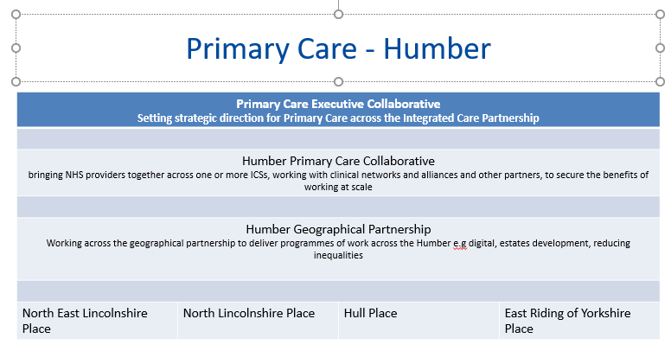

FUNCTIONAL AREAS IN DETAIL

How each functional area will operate in Humber

Function | Place | Humber Strategic Partnership | ICS | Provider Collaborative
Primary care strategy | Co –produce through providing local knowledge and expertise to strategy development  Support deliver y in line with agreed plans and priorities  Support PCNs to reach greater maturity and progress through the PCN Maturity Matrix. | To support development of a collective plan that recognises where places need to level up to impact on health outcomes | Developed through the ICS primary care collaborative | To act as reference/delivery group for strategy development
Primary Care Delegated Commissioning Functions | Implementation of PCCC decisions, business as usual activity and local performance monitoring. | Primary care commissioning functions as per the delegation of functions from NHSE/I (TBA) | ICS with delegated commissioning responsibility for primary care from NHSE/I | Support in planning and development
Local enhanced services | Enhanced services aligned to local need and providing added value through PCN scale delivery. | Standardise across partnership where appropriate and demonstrate impact on health inequalities and delivery of plans |  | Engaged in discussion re LES development
Primary Care Network DES – Contractual and Delivery | Delivery and monitoring of PCN DES and Network Services.  Building capability and capacity through  additional roles | Support alignment with place based integrated models and agreed priorities for recovery and transformation | PCN contract development Specialist support and advice. | Share learning, support delivery through co-production of at scale services
Practice and PCN development and delivering primary care at scale | Support PCNs to reach greater maturity and progress through the PCN Maturity Matrix.  Design and delivery of at scale projects Effective use of population health information Clinician to clinician interface across pathways  Develop Clinical Director leadership capability  Develop management structures to support  delivery – utilise ICS expertise  Integrate with partner organisations to deliver services | Coordinated approach working with federations and PCNs to support consistent and joined up PCN development  Develop consistent approach to PCN engagement  in Place | Developed through the ICS primary care collaborative | Shared learning , support delivery co-production at scale and interface with place development
Primary Care Workforce | Development of additional roles and consistency in terms and conditions  Ensure that each PCN effectively recruit and utilise their full entitlement to support GPs in their workload  Improve access working with the Time for Care team to work in neighbourhoods that are particularly challenged to facilitate improvements.  Increase the understanding of the roles and services provided by provider organisations to meet the needs and ensuring the best use possible of all the skills | Clear understanding of workforce pressures and impact on system and place delivery  Continuation of support for the overseas International GP recruitment scheme to increase the resilience in the East riding/Humber and to support practices with hosting potential new international GPs | Workforce strategy developed through primary care collaborative | Develop innovative employment models
Restoration of Services | Understand the gap - Baseline assessment of current LTC delivery to be established over Q1 with targeted plans to address in quarter 2  Aligned managers working with PCNs  Data Quality in house – support with the above and with implementation of Ardens | Supporting the health and wellbeing of staff in tandem with the Humber LMC to establish scale of the need and work with primary care on a package of support.
COVID Vaccination Programme | Develop plans for phase 3 of the programme | Support PCNs / pharmacies and other so that all adults across the Humber to receive their 2nd dose vaccine by autumn 2021. | RVOC and SVOC
Primary Care Digital Transformation | Place based management and delivery of national digital initiatives  Place based development of digital schemes to support service transformation  Empower patients to take more control over their own health and care | Partnership digital delivery coordination group to ensure join up, shared learning and shared resources linked to HWB digital strategies | Development of digital strategy and deliverables through HCV Digital Board | Rapid development of digital service models
Primary Care and PCN Interface with key priorities | Urgent care transformation  Community diagnostic service development and implementation  DES delivery -Enhanced health in care homes, Early Diagnosis of Cancer, SMR and MO, Extended Access and I&IF | Coordination to support collective development of integrated service models | Links to UECN, Diagnostic Board, Ageing Well  programme | Alignment with work of acute and community providers collaboratives
Population Health Management in primary care | Development of effective business intelligence and  risk stratification to allocate and manage resources  Embed and accelerate learning from PHM development programme  Population Health Hubs to support delivery models | Sharing of best practice and tools on  PHM  Development of joint population health hub forum including shared analytics and toolkits to support PCNs  Assurance of progress against the PHM  maturity matrix in each ‘place’ | Build on system-wide tools (RAIDR, YHCR) to  support resilience in primary care  Links to PHM Board Strategy including levelling-up population outcomes and tackling inequalities | Support system transformation through agreed priorities
Primary Care Estate | Place based strategy and delivery with local partners to develop health and care estate to support service transformation  Development and links to expertise to delivery PIDs and business cases | Develop and agree pipeline for strategic estates programme and priority for submission for capital investment | Budget holder for ICS estates/capital  programmes  ICS-wide estates strategy and planning

