Agenda Item: 8c

Report to: Primary Care Commissioning Committee
Date of meeting: Click or tap to enter a date.
Date paper distributed: 07/12/2021
Subject: Quality update - Blundell Park Surgery
Presented by: Rachel Barrowcliff
Previously distributed to: None

STATUS OF THE REPORT (auto check relevant box)

Decision required ☐
For Discussion to give Assurance ☐ (Only if requested by Committee member prior to meeting)
For Information ☒
Report Exempt from Public Disclosure ☒ No ☐ Yes

PURPOSE OF REPORT: | To update the committee about the latest CQC report published for Blundell Park Surgery and subsequent actions to be taken by the CCG.
Recommendations: | To note the update provided in this report and the actions the CCG is taking to seek assurance from the practice following the most recent CQC inspection report.
Clinical Engagement | The report and actions have been discussed and agreed with the Head of Nursing.
Patient/Public Engagement | Not applicable.
Committee Process and Assurance: | Not applicable.

Link to CCG’s Priorities | - Sustainable services  - Empowering people | ☒  ☐ | - Supporting communities  - Fit for purpose organisation | ☐  ☒
Are there any specific and/or overt risks relating to one or more of the following areas? | - Legal  - Finance  - Quality  - Equality analysis (and Due Regard Duty) | ☐  ☐  ☒  ☐ | - Data protection  - Performance  - Other | ☐  ☐  ☐

Provide a summary of the identified risk
The most recent CQC report details that Blundell Park Surgery has remained with their overall rating as “requires improvement.” The CCG requires assurance from the practice that they will put a robust plan in place to address the deficits in quality and can continue to evidence further progress in the next few months. For this reason, the practice will remain under enhanced surveillance until the CCG is assured that the practice has a robust plan in place and progress is palpable.

Executive Summary

The Committee will be aware that Dr Biswas-Saha’s practice at Blundell Park Surgery received an Inadequate rating following their CQC inspection in July 2019, and publication of the report on 12th September 2019, resulting in the practice being placed into special measures. A focused visit took place in December 2019, where the rating remained as Inadequate.

The second full CQC inspection took place in February 2020, and found that some of the improvements seen in the follow-up inspection had not been sustained and in addition CQC found some other areas of concern. The practice was rated as Requires Improvement overall and remained in special measures.

There was an announced comprehensive inspection in November 2020 and the CQC followed up the breaches of regulations identified at the previous inspection in February of that year. At this point the practice rating remained as Requires Improvement overall because, although there had been improvements since the inspection in February 2020 and some areas had been addressed, some governance arrangements had not been sufficiently implemented and embedded to prevent some additional areas for improvement that was found at this inspection. However, the practice were removed from special measures after this inspection.

Latest update

The CQC undertook a full inspection on 9th September 2021 and the report was published in October 2021; details below:-

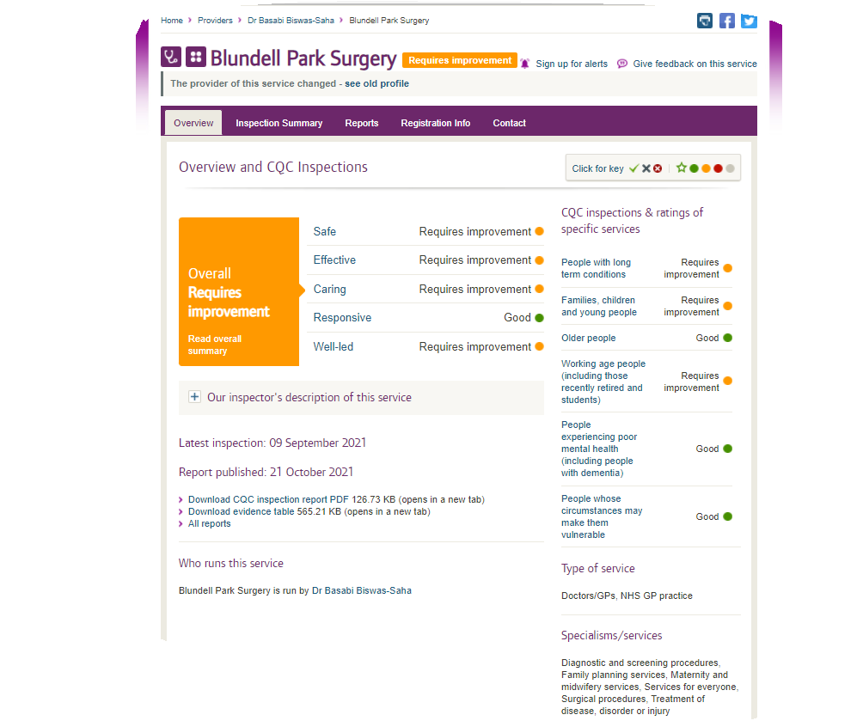

The overall rating remains as Requires Improvement, with the Responsive domain, receiving a Good rating.
The CQC report details that the practice has breached Regulation 17 HSCA (RA) Regulations 2014 Good
Governance, which requires:-

Systems or processes must be established and operated effectively to ensure compliance with the requirements
of the fundamental standards.

How the regulation was not being met:

The registered person had systems or processes in place that operated ineffectively in that they failed to enable
the registered person to assess, monitor and mitigate the risks relating to the health, safety and welfare of service
users and others who may be at risk.

In particular:

- Health and safety recommendations and best practice guidance had not always been fully implemented in relation to fire safety checks and management of risks relating to Legionella because emergency lighting and hot water checks had not been completed.

- Systems to ensure effective care and treatment in relation to monitoring and review of patients with long term conditions and prescribed medicines had not been effectively implemented.

- Patient records relating to medicine reviews and DNACPR decisions were inconsistently completed or lacked detail.

- There was a lack of monitoring to ensure cancer screening and uptake of childhood immunisations were improved in line with local and national averages and/or targets.

Actions agreed

Following the publication of the report, the CCG has reviewed the detail to assess the level of surveillance required.
The CQC has requested an action plan from the practice, which must detail how they will address the issues raised. The CCG has contacted the practice and asked for a copy of the said plan. Once this is received, it will be reviewed and a decision made as to whether sufficient assurance is given.

The Committee will be kept informed regarding the progress against the action plan and any further CQC outcomes.

Recommendation

The Primary Care Commissioning Committee is asked to:-

- Note the update provided in this report and the actions the CCG is taking to seek assurance from the practice that the actions outlined by the CCG are addressed and sustained.

